Training Institute Management System

mini project

Program: B.sc Data Science
Presented By: VEDANTI SANTOSH Shinde
Roll number : 21000
Date: 28-07-2026

Introduction
The Training Institute Management System is a MySQL database project used to manage students, trainers, courses, batches, enrollments, attendance, and assessment results. It reduces paperwork and stores institute data efficiently.

Project Objective
To manage student records, trainers, courses, batches, enrollments, attendance, assessment results, and generate reports.
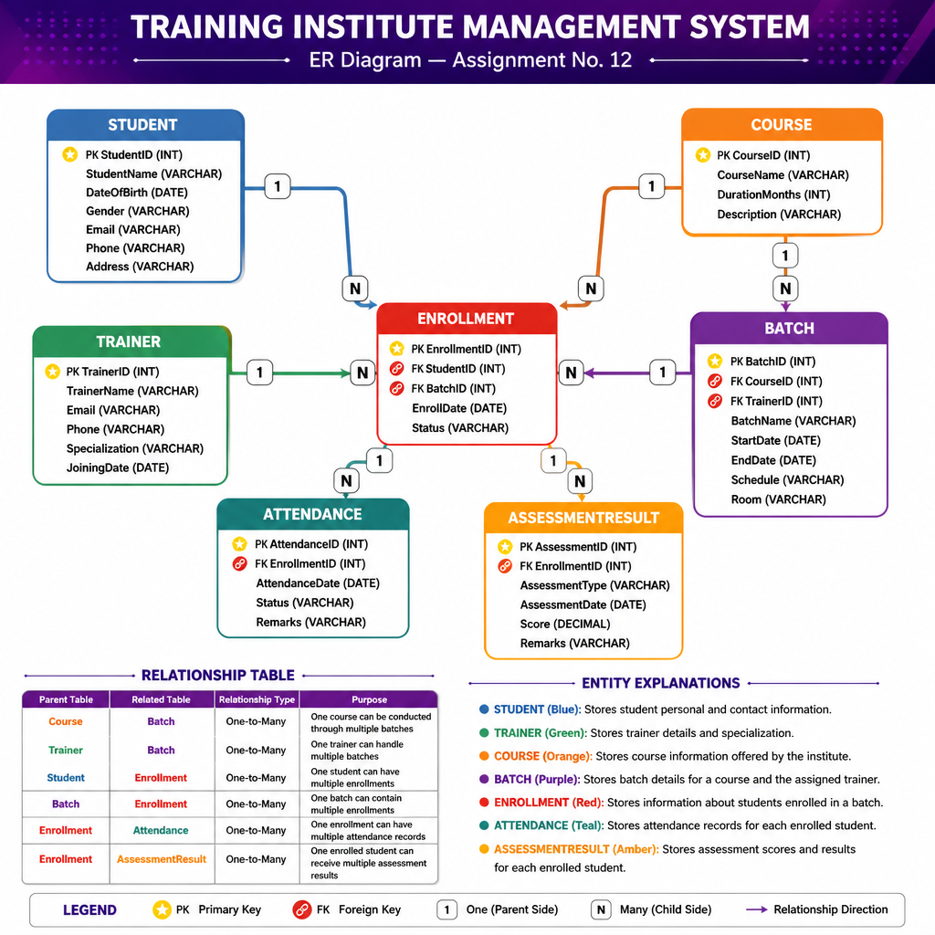
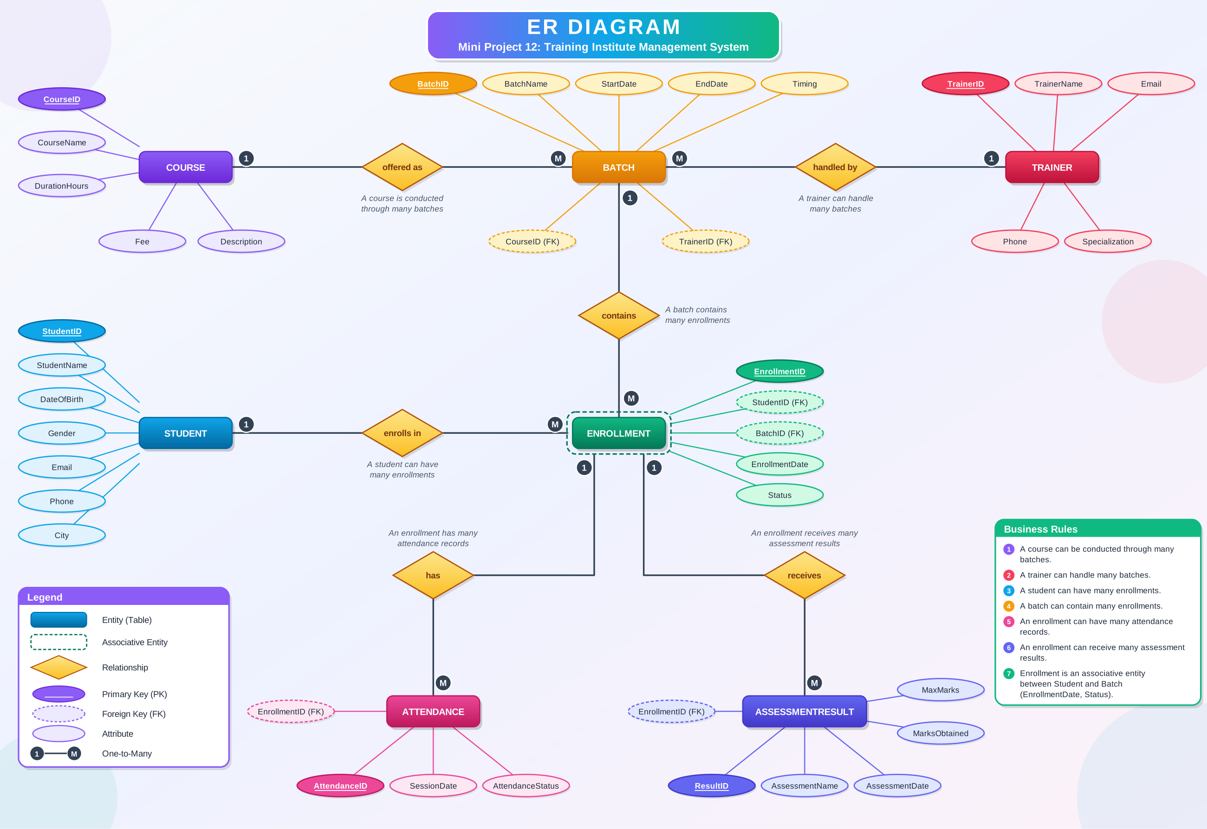

Explanation of ER Diagram
The Entity Relationship Diagram represents the database structure of the Training Institute Management System. It consists of seven entities: Student, Trainer, Course, Batch, Enrollment, Attendance, and AssessmentResult.
Each entity has a primary key that uniquely identifies its records. Foreign keys are used to establish relationships between the entities and maintain referential integrity.
The Course and Trainer tables are connected to the Batch table through one-to-many relationships. The Student and Batch tables are connected to the Enrollment table, which stores student registrations. The Enrollment table is further connected to the Attendance and AssessmentResult tables to maintain attendance records and assessment scores.
This design minimizes data redundancy and helps manage the training institute's operations efficiently.
1. Requirement Analysis and Project Planning
1.1 Main Users of the System

The Training Institute Management System has three main users:
1. Administrator
- Manages student and trainer records.
- Adds and updates course details.
- Creates and manages batches.
- Monitors enrollments and overall institute activities.
2. Trainer
- Views assigned batches and enrolled students.
- Records daily student attendance.
- Enters assessment scores.
- Monitors student performance and progress.
3. Institute Coordinator
- Monitors student enrollment in different courses.
- Reviews attendance and assessment reports.
- Tracks batch progress.
- Identifies students who need additional academic support.

Functional Requirements
The system should provide the following functionalities:
- Student Management: Store, view, and update student information.
- Trainer Management: Maintain trainer details and specialization.
- Course Management: Store course names, durations, and descriptions.
- Batch Management: Create batches and assign courses and trainers.
- Enrollment Management: Register students in batches and track enrollment status.
- Attendance Management: Record and monitor student attendance.
- Assessment Management: Store assessment scores and remarks.
- Report Generation: Generate student, course, batch, attendance, and performance reports.
- Data Integrity: Use primary keys and foreign keys to maintain valid relationships.
- Performance Analysis: Identify high-performing students and students with low attendance or assessment scores.

Expected Reports
The system is expected to generate the following reports:
- Batch-wise student enrollment report.
- Course-wise enrollment summary.
- Trainer-wise batch allocation report.
- Student attendance percentage report.
- Batch-wise average attendance report.
- Student assessment performance report.
- Batch-wise average assessment score report.
- Student ranking report.
- Student-wise training progress report.

Sample Data Planning
The database will use realistic sample records representing a training institute.
The sample dataset will include:
- 10 students
- 3 trainers
- 4 courses
- 4 batches
- Multiple student enrollments
- Attendance records for different training sessions
- Assessment results for enrolled students
This sample data will support the execution of SQL queries and meaningful analysis of enrollment, attendance, and student performance.

Entities
Student, Trainer, Course, Batch, Enrollment, Attendance, AssessmentResult.

Student
Stores StudentID (PK), StudentName, DateOfBirth, Gender, Email, Phone, Address.

Trainer
Stores TrainerID (PK), TrainerName, Email, Phone, Specialization, JoiningDate.

Course
Stores CourseID (PK), CourseName, DurationMonths, Description.

Batch
Stores BatchID (PK), CourseID (FK), TrainerID (FK), BatchName, StartDate, EndDate, Schedule, Room.

Enrollment
Bridge table connecting Student and Batch. Stores EnrollmentID (PK), StudentID (FK), BatchID (FK), EnrollDate, Status.

Attendance
Stores AttendanceID (PK), EnrollmentID (FK), AttendanceDate, Status, Remarks.

AssessmentResult
Stores AssessmentID (PK), EnrollmentID (FK), AssessmentType, AssessmentDate, Score, Remarks.

Relationships
Course→Batch (1:N), Trainer→Batch (1:N), Student→Enrollment (1:N), Batch→Enrollment (1:N), Enrollment→Attendance (1:N), Enrollment→AssessmentResult (1:N).

Database Schema
The tables below implement the entities and relationships described above as a MySQL relational schema.

Student Table
CREATE TABLE Student (
StudentID INT PRIMARY KEY AUTO_INCREMENT,
StudentName VARCHAR(100) NOT NULL,
DateOfBirth DATE,
Gender ENUM('Male','Female','Other'),
Email VARCHAR(100) UNIQUE,
Phone VARCHAR(15),
Address VARCHAR(255)
);
INSERT INTO student
(StudentName, DateOfBirth, Gender, Email, Phone, Address)
VALUES
('Aarav Sharma', '2004-05-12', 'Male', 'aarav@gmail.com', '9876501001', 'Pune'),
('Priya Patil', '2003-08-21', 'Female', 'priya@gmail.com', '9876501002', 'Mumbai'),
('Rohan Deshmukh', '2004-01-15', 'Male', 'rohan@gmail.com', '9876501003', 'Pune'),
('Sneha Kulkarni', '2003-11-30', 'Female', 'sneha@gmail.com', '9876501004', 'Nashik'),
('Aditya Joshi', '2004-03-18', 'Male', 'aditya@gmail.com', '9876501005', 'Pune'),
('Ananya Shah', '2003-07-09', 'Female', 'ananya@gmail.com', '9876501006', 'Mumbai'),
('Omkar Jadhav', '2004-09-25', 'Male', 'omkar@gmail.com', '9876501007', 'Satara'),
('Kavya Mehta', '2003-04-14', 'Female', 'kavya@gmail.com', '9876501008', 'Pune'),
('Ishaan More', '2004-12-05', 'Male', 'ishaan@gmail.com', '9876501009', 'Kolhapur'),
('Neha Pawar', '2003-06-17', 'Female', 'neha@gmail.com', '9876501010', 'Pune');
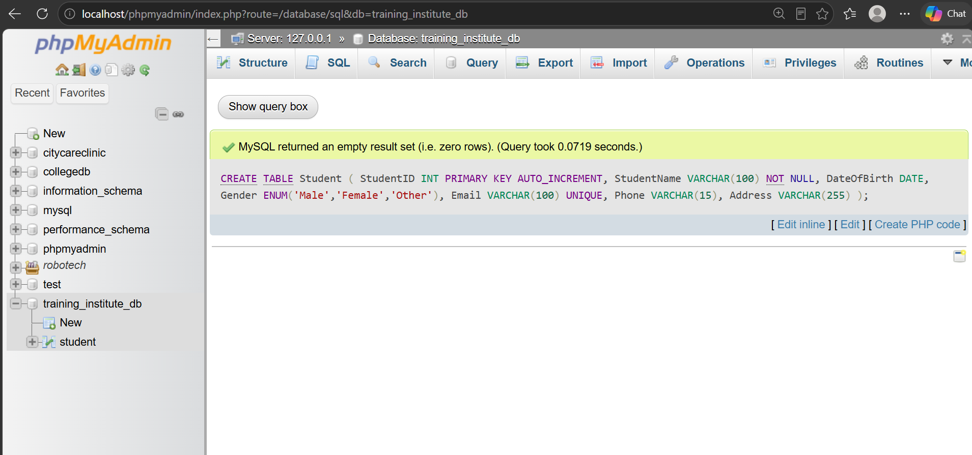
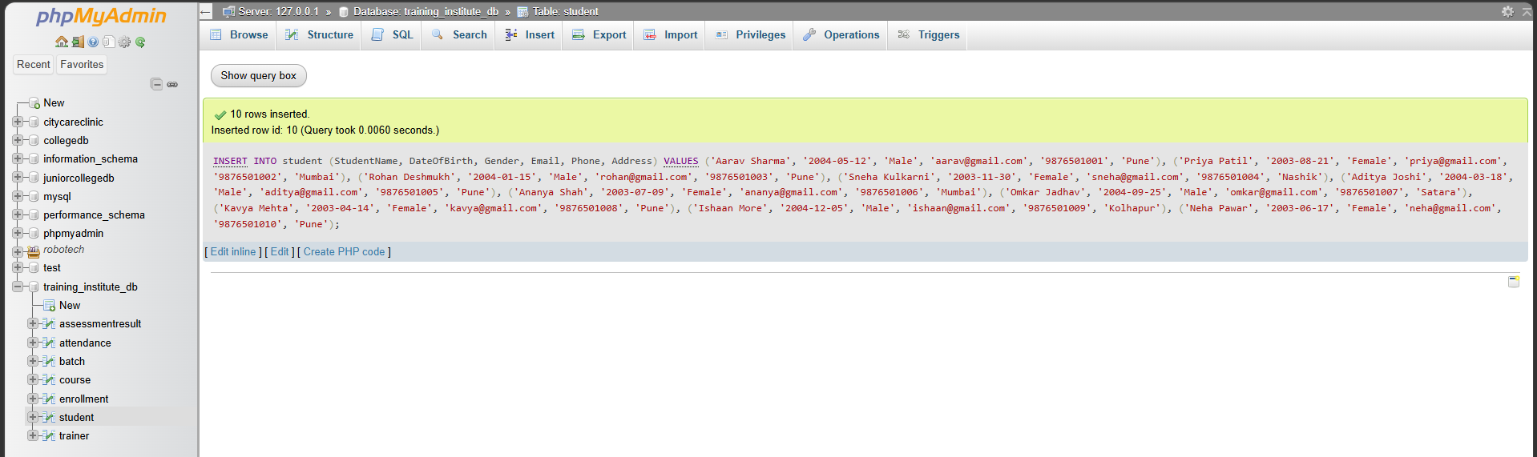

Trainer Table
CREATE TABLE Trainer (
TrainerID INT PRIMARY KEY AUTO_INCREMENT,
TrainerName VARCHAR(100) NOT NULL,
Email VARCHAR(100) UNIQUE,
Phone VARCHAR(15),
Specialization VARCHAR(100),
JoiningDate DATE
);
INSERT INTO trainer
(TrainerName, Email, Phone, Specialization, JoiningDate)
VALUES
('Rahul Kulkarni', 'rahul.trainer@gmail.com', '9876511001', 'Python Programming', '2023-01-10'),
('Meera Joshi', 'meera.trainer@gmail.com', '9876511002', 'Data Analytics', '2022-06-15'),
('Amit Desai', 'amit.trainer@gmail.com', '9876511003', 'Database Management', '2024-02-01');
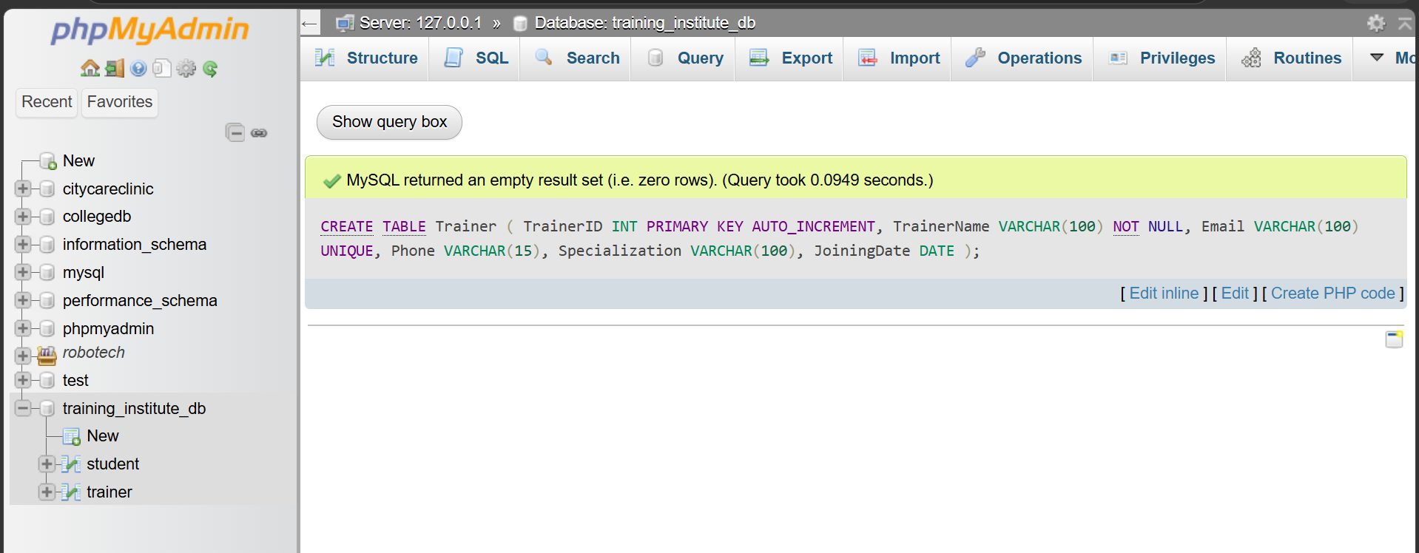
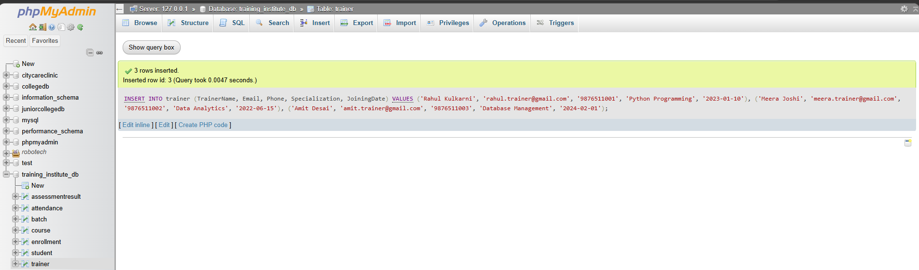

Course Table
CREATE TABLE Course (
CourseID INT PRIMARY KEY AUTO_INCREMENT,
CourseName VARCHAR(100) NOT NULL,
DurationMonths INT,
Description VARCHAR(255)
);
INSERT INTO course
(CourseName, DurationMonths, Description)
VALUES
('Python Programming', 3, 'Fundamentals and advanced Python programming'),
('Data Analytics', 4, 'Data analysis using Excel, SQL and visualization'),
('Database Management', 3, 'SQL and relational database concepts'),
('Web Development', 6, 'Frontend and backend web development');

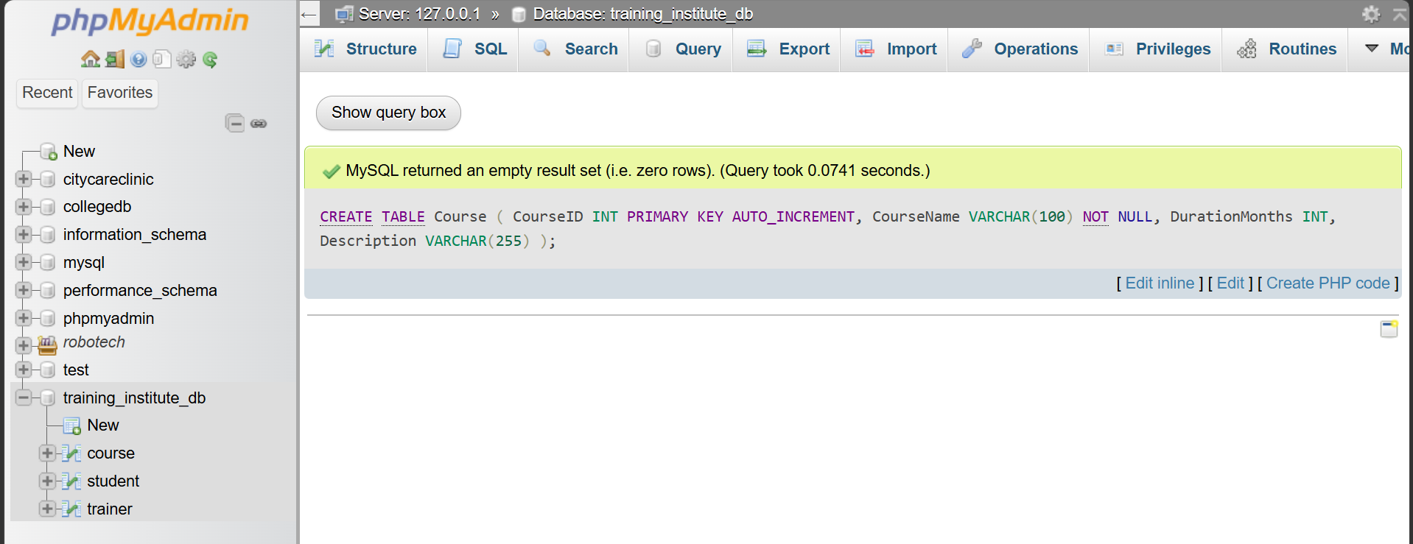
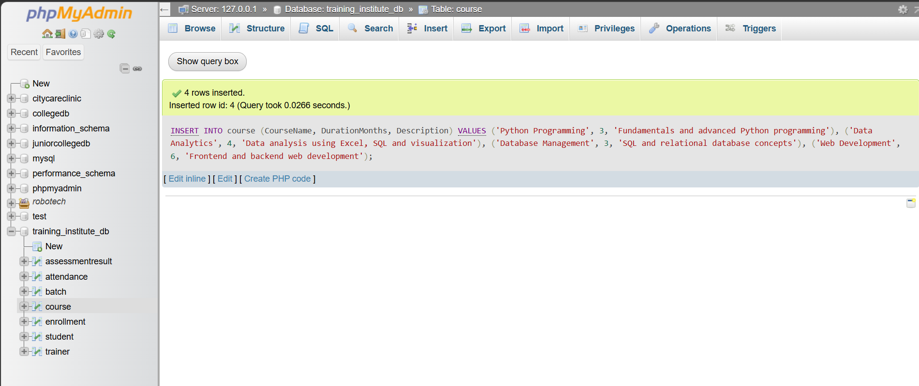
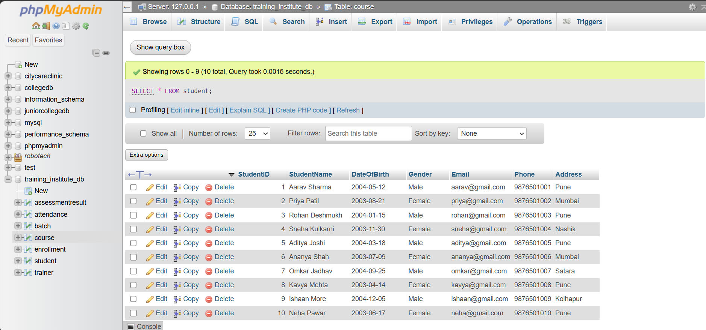

Batch Table
CREATE TABLE Batch (
BatchID INT PRIMARY KEY AUTO_INCREMENT,
CourseID INT NOT NULL,
TrainerID INT NOT NULL,
BatchName VARCHAR(100),
StartDate DATE,
EndDate DATE,
Schedule VARCHAR(100),
Room VARCHAR(20),
FOREIGN KEY (CourseID) REFERENCES Course(CourseID),
FOREIGN KEY (TrainerID) REFERENCES Trainer(TrainerID)
);
INSERT INTO batch
(CourseID, TrainerID, BatchName, StartDate, EndDate, Schedule, Room)
VALUES
(
(SELECT CourseID FROM course WHERE CourseName='Python Programming'),
(SELECT TrainerID FROM trainer WHERE TrainerName='Rahul Kulkarni'),
'Python Morning Batch',
'2026-01-01', '2026-03-31', '9 AM - 11 AM', 'Room 101'
),
(
(SELECT CourseID FROM course WHERE CourseName='Data Analytics'),
(SELECT TrainerID FROM trainer WHERE TrainerName='Meera Joshi'),
'Analytics Evening Batch',
'2026-02-01', '2026-05-31', '2 PM - 4 PM', 'Room 102'
),
(
(SELECT CourseID FROM course WHERE CourseName='Database Management'),
(SELECT TrainerID FROM trainer WHERE TrainerName='Amit Desai'),
'SQL Weekend Batch',
'2026-03-01', '2026-05-31', '10 AM - 12 PM', 'Room 103'
),
(
(SELECT CourseID FROM course WHERE CourseName='Web Development'),
(SELECT TrainerID FROM trainer WHERE TrainerName='Rahul Kulkarni'),
'Web Development Batch',
'2026-04-01', '2026-09-30', '11 AM - 1 PM', 'Room 104'
);
SELECT
b.BatchID,
b.BatchName,
c.CourseName,
t.TrainerName,
b.StartDate,
b.EndDate,
b.Schedule,
b.Room
FROM batch b
JOIN course c ON b.CourseID = c.CourseID
JOIN trainer t ON b.TrainerID = t.TrainerID;

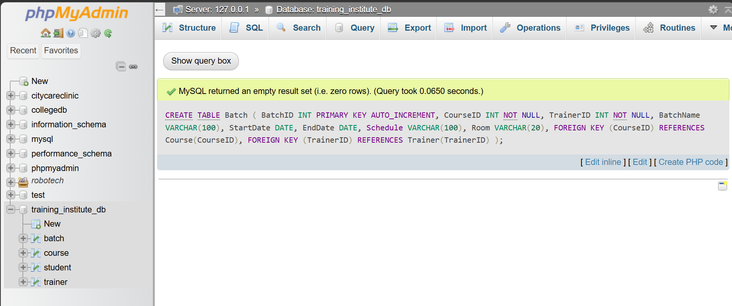

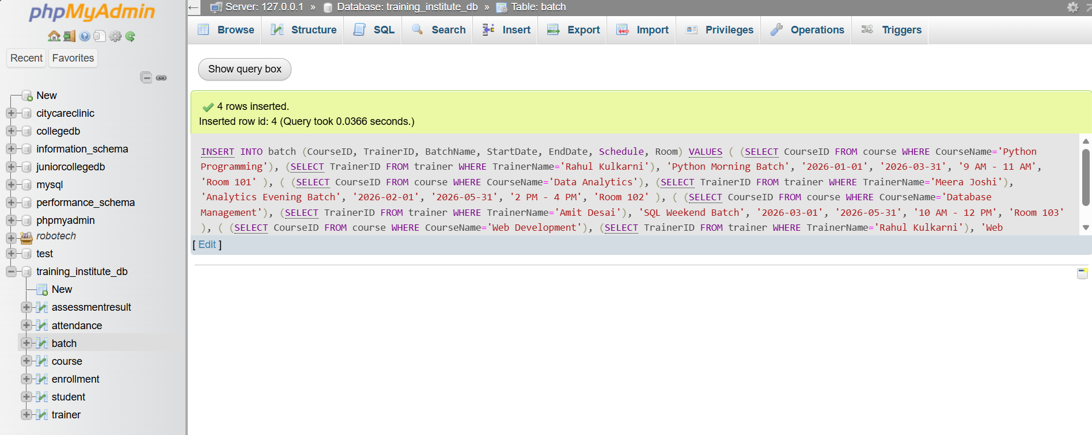
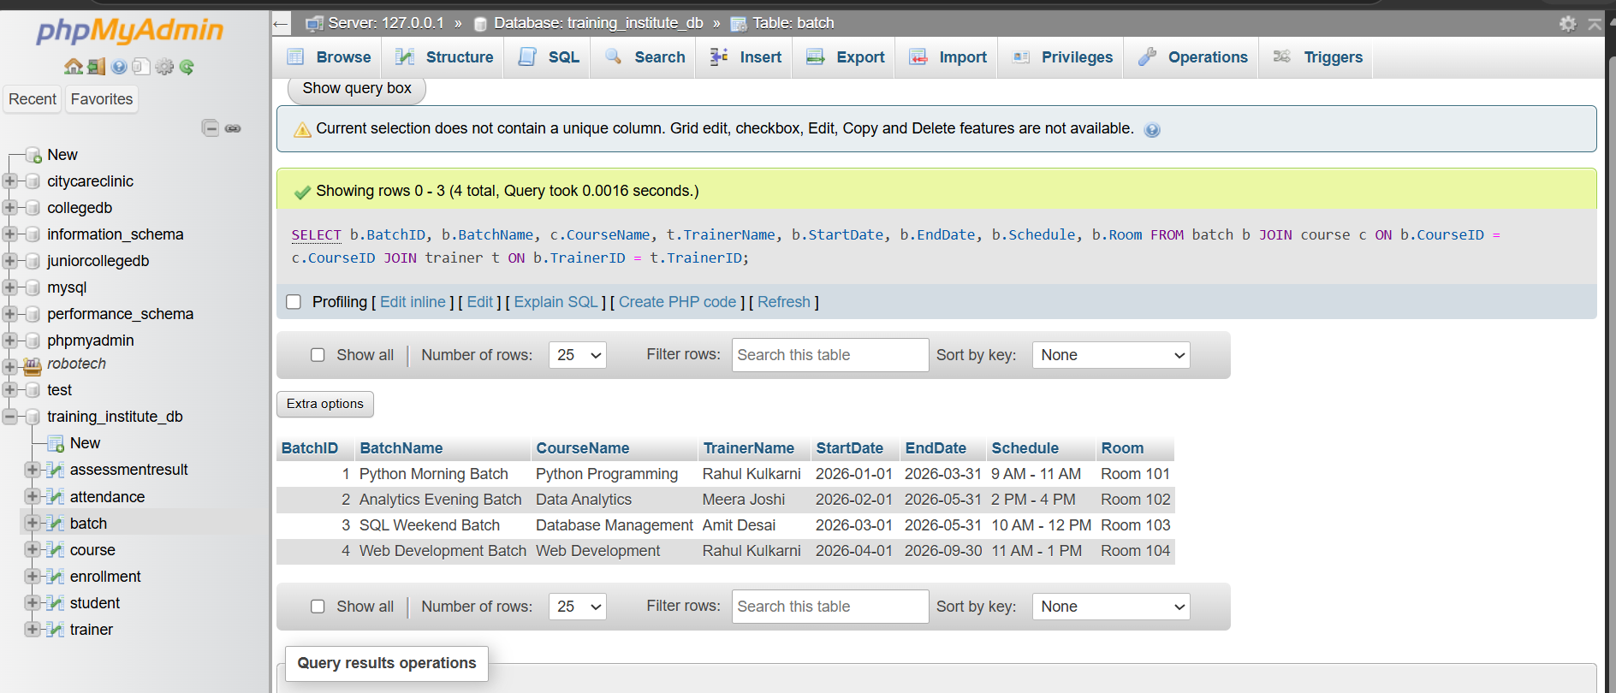

Enrollment Table
CREATE TABLE Enrollment (
EnrollmentID INT PRIMARY KEY AUTO_INCREMENT,
StudentID INT NOT NULL,
BatchID INT NOT NULL,
EnrollDate DATE,
Status ENUM('Active','Completed','Dropped'),
FOREIGN KEY (StudentID) REFERENCES Student(StudentID),
FOREIGN KEY (BatchID) REFERENCES Batch(BatchID)
);
INSERT INTO enrollment
(StudentID, BatchID, EnrollDate, Status)
VALUES
(
(SELECT StudentID FROM student WHERE StudentName='Aarav Sharma'),
(SELECT BatchID FROM batch WHERE BatchName='Python Morning Batch'),
'2026-01-02', 'Active'
),
(
(SELECT StudentID FROM student WHERE StudentName='Priya Patil'),
(SELECT BatchID FROM batch WHERE BatchName='Python Morning Batch'),
'2026-01-03', 'Active'
),
(
(SELECT StudentID FROM student WHERE StudentName='Rohan Deshmukh'),
(SELECT BatchID FROM batch WHERE BatchName='Python Morning Batch'),
'2026-01-04', 'Active'
),
(
(SELECT StudentID FROM student WHERE StudentName='Sneha Kulkarni'),
(SELECT BatchID FROM batch WHERE BatchName='Analytics Evening Batch'),
'2026-02-02', 'Active'
),
(
(SELECT StudentID FROM student WHERE StudentName='Aditya Joshi'),
(SELECT BatchID FROM batch WHERE BatchName='Analytics Evening Batch'),
'2026-02-03', 'Active'
),
(
(SELECT StudentID FROM student WHERE StudentName='Ananya Shah'),
(SELECT BatchID FROM batch WHERE BatchName='Analytics Evening Batch'),
'2026-02-04', 'Active'
),
(
(SELECT StudentID FROM student WHERE StudentName='Omkar Jadhav'),
(SELECT BatchID FROM batch WHERE BatchName='SQL Weekend Batch'),
'2026-03-02', 'Active'
),
(
(SELECT StudentID FROM student WHERE StudentName='Kavya Mehta'),
(SELECT BatchID FROM batch WHERE BatchName='SQL Weekend Batch'),
'2026-03-03', 'Active'
),
(
(SELECT StudentID FROM student WHERE StudentName='Ishaan More'),
(SELECT BatchID FROM batch WHERE BatchName='Web Development Batch'),
'2026-04-02', 'Active'
),
(
(SELECT StudentID FROM student WHERE StudentName='Neha Pawar'),
(SELECT BatchID FROM batch WHERE BatchName='Web Development Batch'),
'2026-04-03', 'Active'
);
SELECT
e.EnrollmentID,
s.StudentName,
b.BatchName,
c.CourseName,
e.EnrollDate,
e.Status
FROM enrollment e
JOIN student s ON e.StudentID = s.StudentID
JOIN batch b ON e.BatchID = b.BatchID
JOIN course c ON b.CourseID = c.CourseID
ORDER BY b.BatchName, s.StudentName;
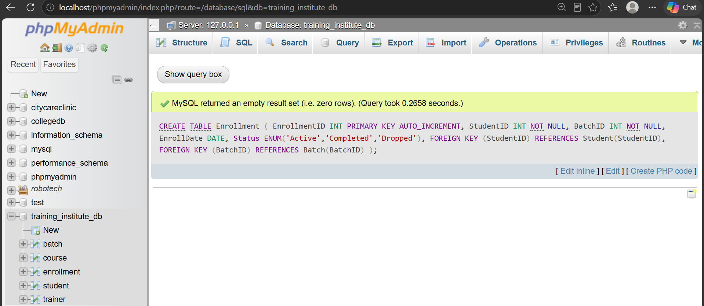

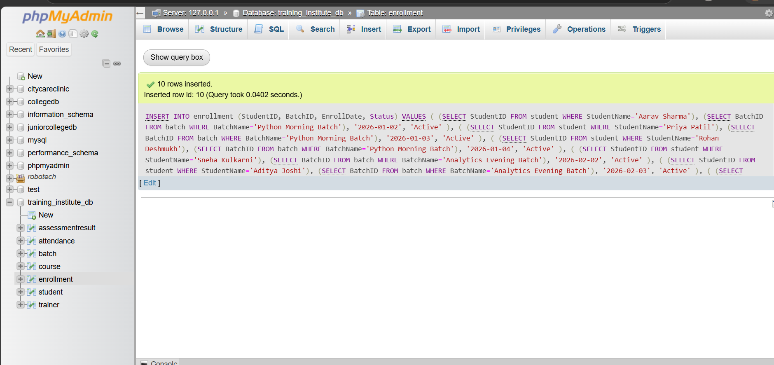

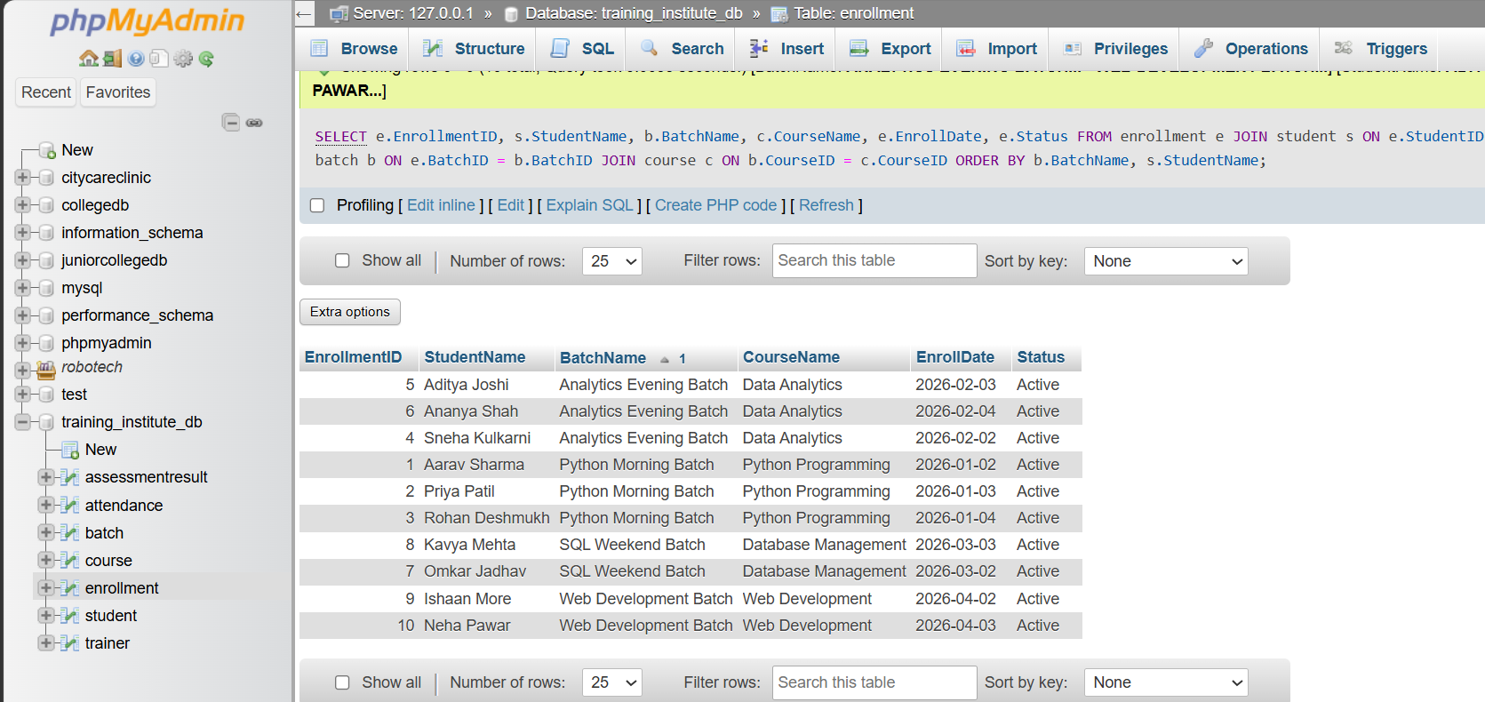Attendance Table
CREATE TABLE Attendance (
AttendanceID INT PRIMARY KEY AUTO_INCREMENT,
EnrollmentID INT NOT NULL,
AttendanceDate DATE,
Status ENUM('Present','Absent','Late'),
Remarks VARCHAR(255),
FOREIGN KEY (EnrollmentID) REFERENCES Enrollment(EnrollmentID)
);
INSERT INTO attendance
(EnrollmentID, AttendanceDate, Status, Remarks)
SELECT
e.EnrollmentID,
a.AttendanceDate,
a.Status,
a.Remarks
FROM
(
SELECT 'Aarav Sharma' AS StudentName, 'Python Morning Batch' AS BatchName,
'2026-01-05' AS AttendanceDate, 'Present' AS Status, 'Attended session' AS Remarks
UNION ALL
SELECT 'Aarav Sharma', 'Python Morning Batch', '2026-01-10', 'Present', 'Attended session'
UNION ALL
SELECT 'Aarav Sharma', 'Python Morning Batch', '2026-01-15', 'Present', 'Attended session'
UNION ALL
SELECT 'Priya Patil', 'Python Morning Batch', '2026-01-05', 'Present', 'Attended session'
UNION ALL
SELECT 'Priya Patil', 'Python Morning Batch', '2026-01-10', 'Absent', 'Absent from session'
UNION ALL
SELECT 'Priya Patil', 'Python Morning Batch', '2026-01-15', 'Present', 'Attended session'
UNION ALL
SELECT 'Rohan Deshmukh', 'Python Morning Batch', '2026-01-05', 'Absent', 'Absent from session'
UNION ALL
SELECT 'Rohan Deshmukh', 'Python Morning Batch', '2026-01-10', 'Absent', 'Absent from session'
UNION ALL
SELECT 'Rohan Deshmukh', 'Python Morning Batch', '2026-01-15', 'Present', 'Attended session'
UNION ALL
SELECT 'Sneha Kulkarni', 'Analytics Evening Batch', '2026-02-05', 'Present', 'Attended session'
UNION ALL
SELECT 'Sneha Kulkarni', 'Analytics Evening Batch', '2026-02-10', 'Present', 'Attended session'
UNION ALL
SELECT 'Sneha Kulkarni', 'Analytics Evening Batch', '2026-02-15', 'Present', 'Attended session'
UNION ALL
SELECT 'Aditya Joshi', 'Analytics Evening Batch', '2026-02-05', 'Present', 'Attended session'
UNION ALL
SELECT 'Aditya Joshi', 'Analytics Evening Batch', '2026-02-10', 'Late', 'Arrived late'
UNION ALL
SELECT 'Aditya Joshi', 'Analytics Evening Batch', '2026-02-15', 'Absent', 'Absent from session'
UNION ALL
SELECT 'Ananya Shah', 'Analytics Evening Batch', '2026-02-05', 'Absent', 'Absent from session'
UNION ALL
SELECT 'Ananya Shah', 'Analytics Evening Batch', '2026-02-10', 'Absent', 'Absent from session'
UNION ALL
SELECT 'Ananya Shah', 'Analytics Evening Batch', '2026-02-15', 'Absent', 'Absent from session'
UNION ALL
SELECT 'Omkar Jadhav', 'SQL Weekend Batch', '2026-03-07', 'Present', 'Attended session'
UNION ALL
SELECT 'Omkar Jadhav', 'SQL Weekend Batch', '2026-03-14', 'Present', 'Attended session'
UNION ALL
SELECT 'Omkar Jadhav', 'SQL Weekend Batch', '2026-03-21', 'Present', 'Attended session'
UNION ALL
SELECT 'Kavya Mehta', 'SQL Weekend Batch', '2026-03-07', 'Present', 'Attended session'
UNION ALL
SELECT 'Kavya Mehta', 'SQL Weekend Batch', '2026-03-14', 'Absent', 'Absent from session'
UNION ALL
SELECT 'Kavya Mehta', 'SQL Weekend Batch', '2026-03-21', 'Present', 'Attended session'
UNION ALL
SELECT 'Ishaan More', 'Web Development Batch', '2026-04-05', 'Present', 'Attended session'
UNION ALL
SELECT 'Ishaan More', 'Web Development Batch', '2026-04-12', 'Present', 'Attended session'
UNION ALL
SELECT 'Ishaan More', 'Web Development Batch', '2026-04-19', 'Present', 'Attended session'
UNION ALL
SELECT 'Neha Pawar', 'Web Development Batch', '2026-04-05', 'Absent', 'Absent from session'
UNION ALL
SELECT 'Neha Pawar', 'Web Development Batch', '2026-04-12', 'Present', 'Attended session'
UNION ALL
SELECT 'Neha Pawar', 'Web Development Batch', '2026-04-19', 'Absent', 'Absent from session'
) AS a
JOIN student s ON s.StudentName = a.StudentName
JOIN batch b ON b.BatchName = a.BatchName
JOIN enrollment e
ON e.StudentID = s.StudentID
AND e.BatchID = b.BatchID;
SELECT
a.AttendanceID,
s.StudentName,
b.BatchName,
a.AttendanceDate,
a.Status,
a.Remarks
FROM attendance a
JOIN enrollment e ON a.EnrollmentID = e.EnrollmentID
JOIN student s ON e.StudentID = s.StudentID
JOIN batch b ON e.BatchID = b.BatchID
ORDER BY b.BatchName, s.StudentName, a.AttendanceDate;

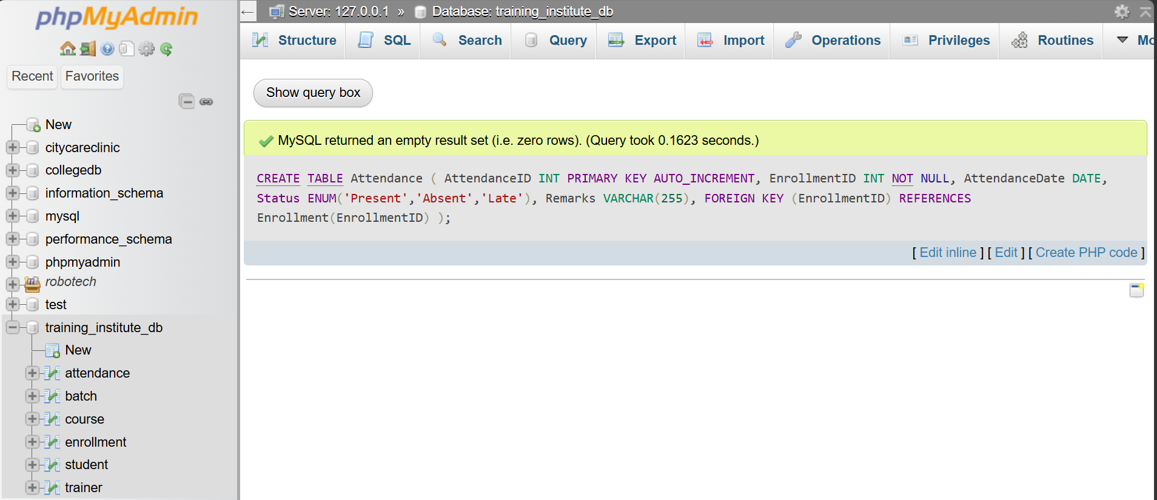

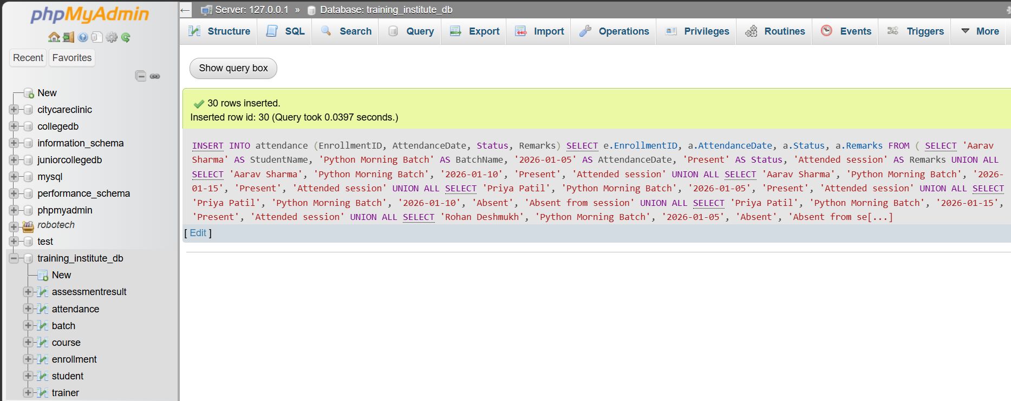

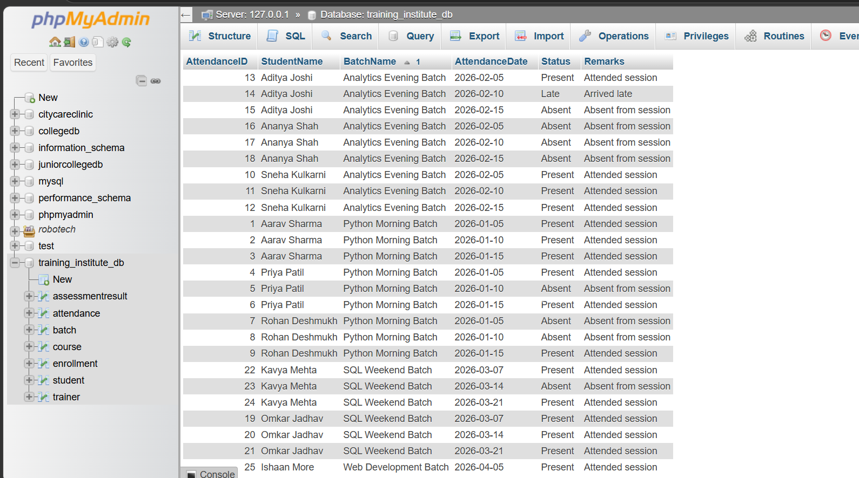AssessmentResult Table
CREATE TABLE AssessmentResult (
AssessmentID INT PRIMARY KEY AUTO_INCREMENT,
EnrollmentID INT NOT NULL,
AssessmentType VARCHAR(50),
AssessmentDate DATE,
Score DECIMAL(5,2),
Remarks VARCHAR(255),
FOREIGN KEY (EnrollmentID) REFERENCES Enrollment(EnrollmentID)
);
INSERT INTO assessmentresult
(EnrollmentID, AssessmentType, AssessmentDate, Score, Remarks)
SELECT
e.EnrollmentID,
a.AssessmentType,
a.AssessmentDate,
a.Score,
a.Remarks
FROM
(
SELECT 'Aarav Sharma' AS StudentName, 'Python Morning Batch' AS BatchName,
'Assignment' AS AssessmentType, '2026-02-01' AS AssessmentDate,
92 AS Score, 'Excellent performance' AS Remarks
UNION ALL
SELECT 'Aarav Sharma', 'Python Morning Batch', 'Final Test', '2026-03-15', 95, 'Outstanding'
UNION ALL
SELECT 'Priya Patil', 'Python Morning Batch', 'Assignment', '2026-02-01', 85, 'Good performance'
UNION ALL
SELECT 'Priya Patil', 'Python Morning Batch', 'Final Test', '2026-03-15', 88, 'Very good'
UNION ALL
SELECT 'Rohan Deshmukh', 'Python Morning Batch', 'Assignment', '2026-02-01', 55, 'Needs improvement'
UNION ALL
SELECT 'Rohan Deshmukh', 'Python Morning Batch', 'Final Test', '2026-03-15', 60, 'Average performance'
UNION ALL
SELECT 'Sneha Kulkarni', 'Analytics Evening Batch', 'Assignment', '2026-04-01', 96, 'Excellent'
UNION ALL
SELECT 'Sneha Kulkarni', 'Analytics Evening Batch', 'Final Test', '2026-05-15', 98, 'Outstanding'
UNION ALL
SELECT 'Aditya Joshi', 'Analytics Evening Batch', 'Assignment', '2026-04-01', 78, 'Good'
UNION ALL
SELECT 'Aditya Joshi', 'Analytics Evening Batch', 'Final Test', '2026-05-15', 75, 'Satisfactory'
UNION ALL
SELECT 'Ananya Shah', 'Analytics Evening Batch', 'Assignment', '2026-04-01', 45, 'Needs improvement'
UNION ALL
SELECT 'Ananya Shah', 'Analytics Evening Batch', 'Final Test', '2026-05-15', 50, 'Requires additional support'
UNION ALL
SELECT 'Omkar Jadhav', 'SQL Weekend Batch', 'Assignment', '2026-04-15', 89, 'Very good'
UNION ALL
SELECT 'Omkar Jadhav', 'SQL Weekend Batch', 'Final Test', '2026-05-20', 94, 'Excellent'
UNION ALL
SELECT 'Kavya Mehta', 'SQL Weekend Batch', 'Assignment', '2026-04-15', 82, 'Good'
UNION ALL
SELECT 'Kavya Mehta', 'SQL Weekend Batch', 'Final Test', '2026-05-20', 86, 'Very good'
UNION ALL
SELECT 'Ishaan More', 'Web Development Batch', 'Assignment', '2026-06-15', 91, 'Excellent'
UNION ALL
SELECT 'Ishaan More', 'Web Development Batch', 'Final Test', '2026-08-15', 93, 'Outstanding'
UNION ALL
SELECT 'Neha Pawar', 'Web Development Batch', 'Assignment', '2026-06-15', 65, 'Average'
UNION ALL
SELECT 'Neha Pawar', 'Web Development Batch', 'Final Test', '2026-08-15', 58, 'Needs improvement'
) AS a
JOIN student s
ON s.StudentName = a.StudentName
JOIN batch b
ON b.BatchName = a.BatchName
JOIN enrollment e
ON e.StudentID = s.StudentID
AND e.BatchID = b.BatchID;
SELECT
ar.AssessmentID,
s.StudentName,
b.BatchName,
ar.AssessmentType,
ar.AssessmentDate,
ar.Score,
ar.Remarks
FROM assessmentresult ar
JOIN enrollment e
ON ar.EnrollmentID = e.EnrollmentID
JOIN student s
ON e.StudentID = s.StudentID
JOIN batch b
ON e.BatchID = b.BatchID
ORDER BY b.BatchName, s.StudentName, ar.AssessmentDate;

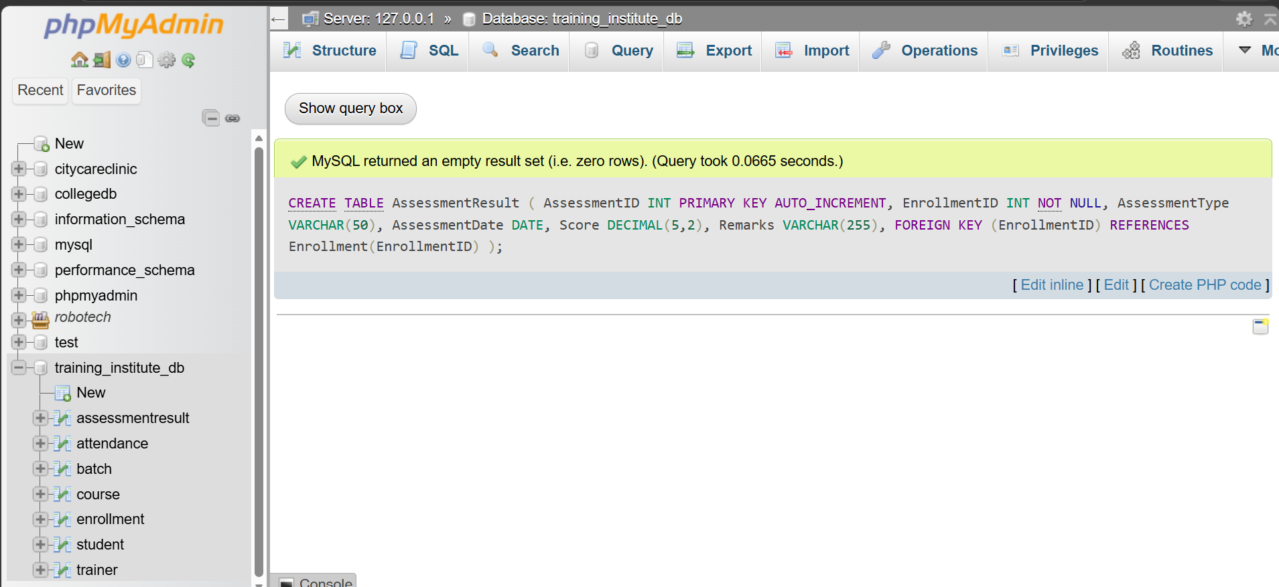

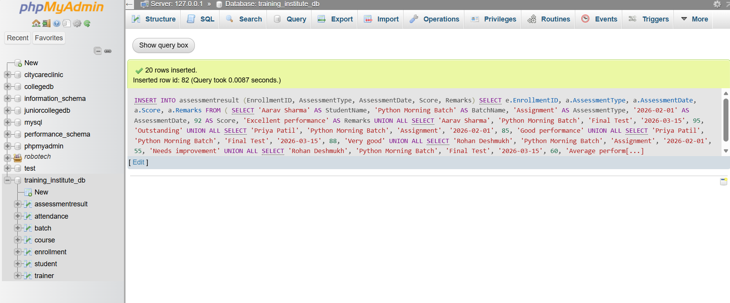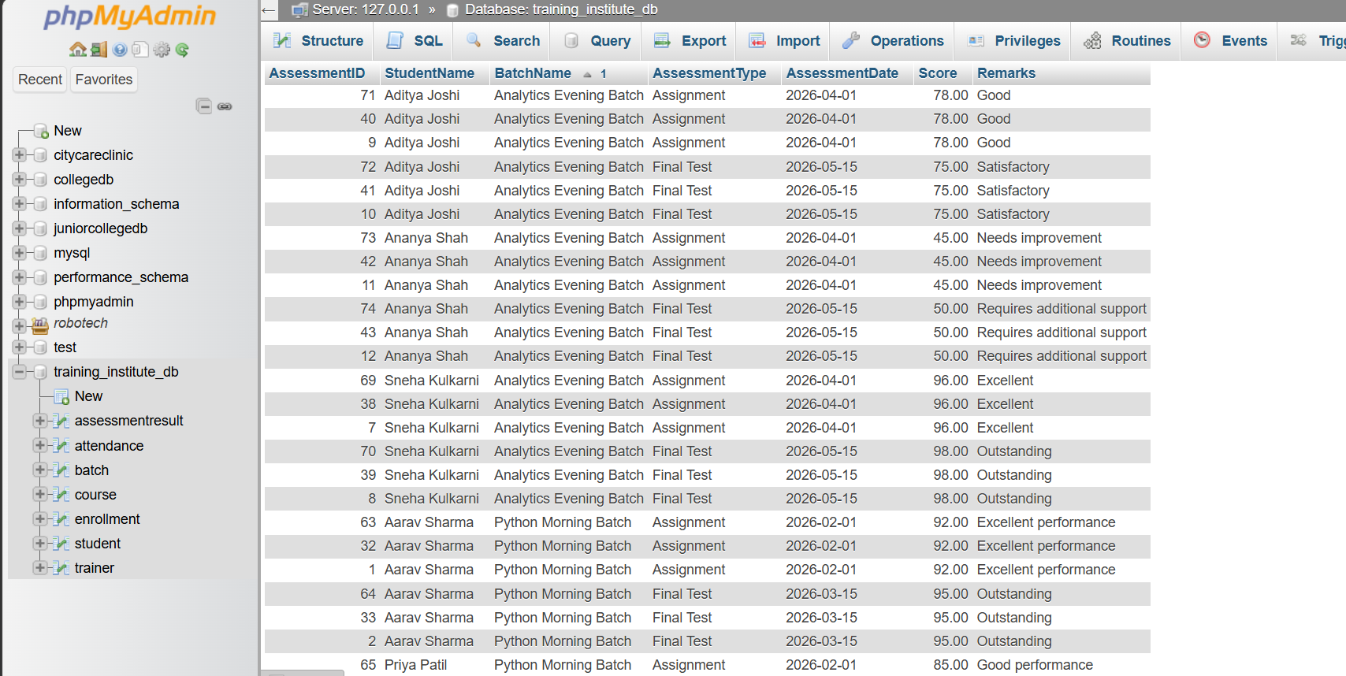

Query 1: Total Number of Students in Each Batch
SELECT
b.BatchName,
COUNT(e.EnrollmentID) AS TotalStudents
FROM batch b
LEFT JOIN enrollment e
ON b.BatchID = e.BatchID
GROUP BY b.BatchID, b.BatchName;
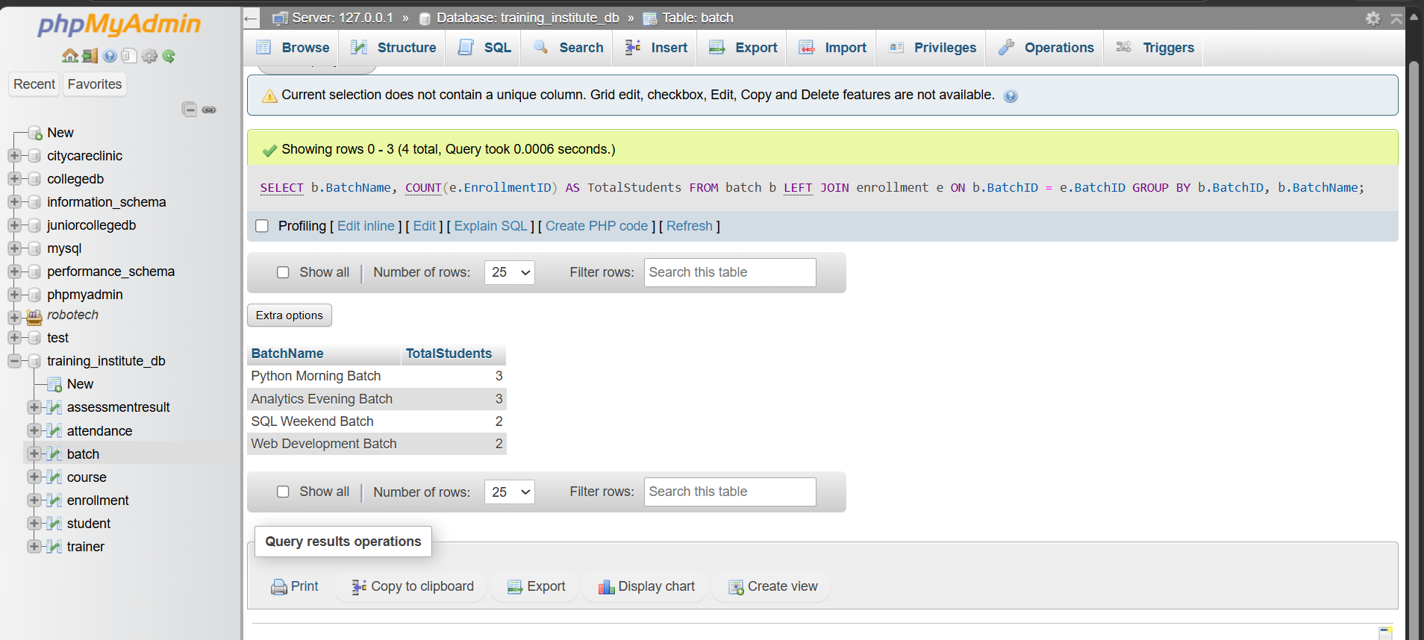
Observation: The Python Morning Batch and Analytics Evening Batch have the highest enrollment, with 3 students each. The SQL Weekend Batch and Web Development Batch have 2 students each.

Query 2 — Display student details with their course and batch
SELECT
s.StudentID,
s.StudentName,
c.CourseName,
b.BatchName,
e.EnrollDate,
e.Status
FROM student s
JOIN enrollment e
ON s.StudentID = e.StudentID
JOIN batch b
ON e.BatchID = b.BatchID
JOIN course c
ON b.CourseID = c.CourseID
ORDER BY s.StudentID;
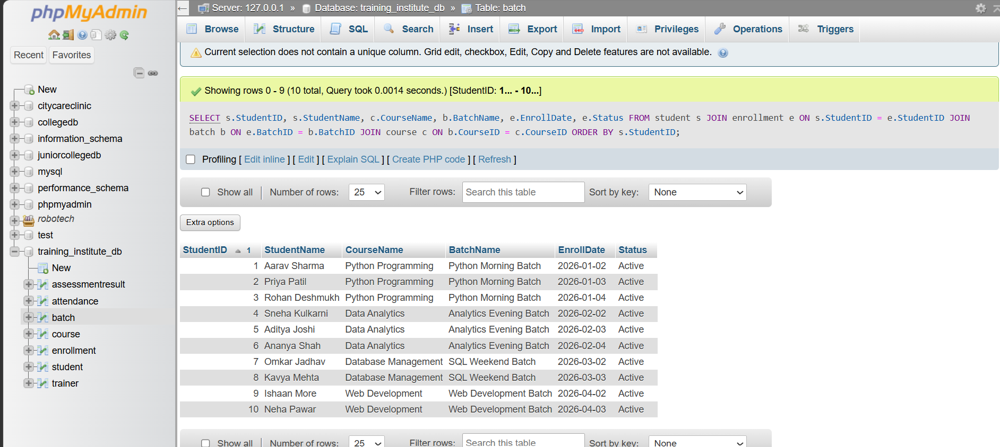
Observation: The query successfully combines four tables using JOIN operations. It provides a consolidated view of students, their enrolled courses, batches, and enrollment status.

Query 3 — Calculate average assessment score for each course
SELECT
c.CourseName,
ROUND(AVG(a.Score), 2) AS AverageScore
FROM course c
JOIN batch b
ON c.CourseID = b.CourseID
JOIN enrollment e
ON b.BatchID = e.BatchID
JOIN assessmentresult a
ON e.EnrollmentID = a.EnrollmentID
GROUP BY c.CourseID, c.CourseName;

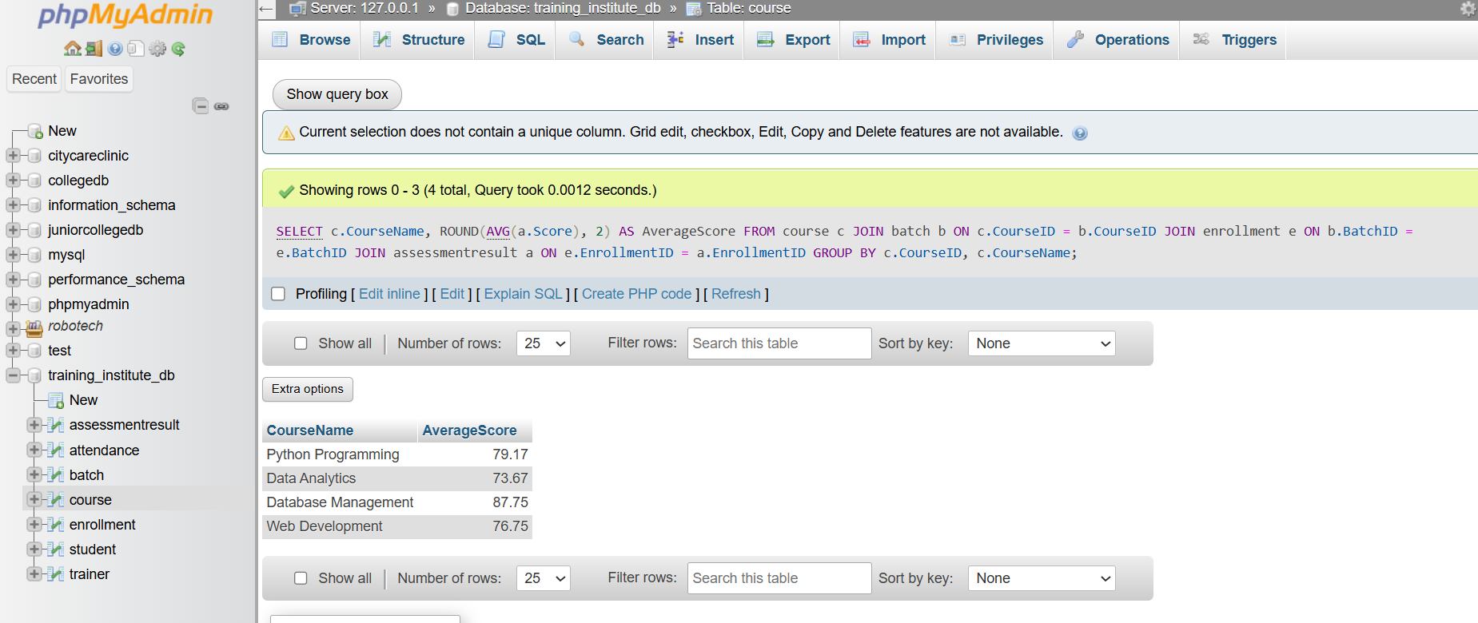Observation: Database Management has the highest average assessment score of 87.75, while Data Analytics has the lowest average of 73.67 among the four courses.

Query 4 — Find students with attendance below 75%
SELECT
s.StudentName,
ROUND(
SUM(CASE WHEN a.Status = 'Present' THEN 1 ELSE 0 END) * 100.0
/ COUNT(a.AttendanceID), 2
) AS AttendancePercentage
FROM student s
JOIN enrollment e
ON s.StudentID = e.StudentID
JOIN attendance a
ON e.EnrollmentID = a.EnrollmentID
GROUP BY s.StudentID, s.StudentName
HAVING AttendancePercentage < 75;
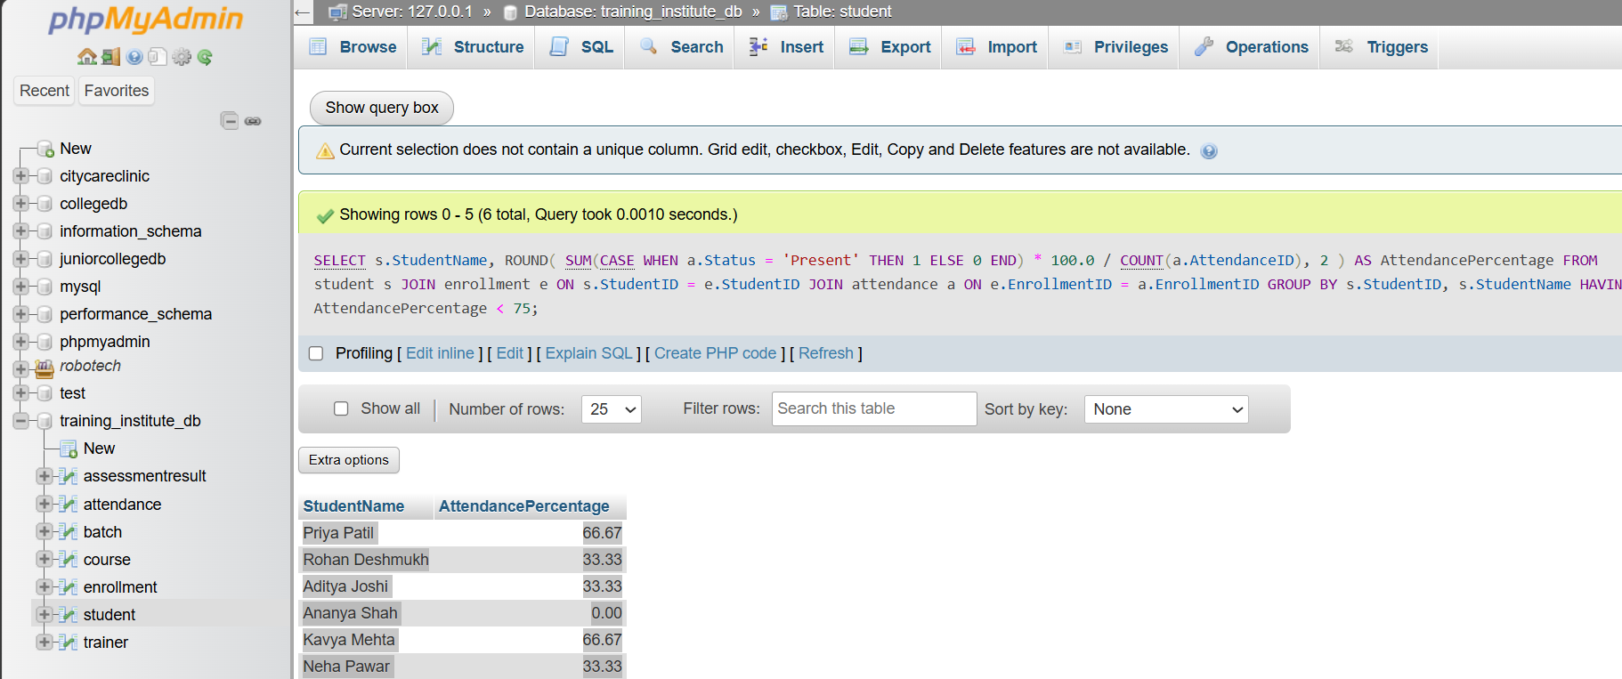
Observation: Six students have attendance below 75%. Ananya Shah has the lowest attendance at 0%, while Priya Patil and Kavya Mehta have 66.67% each.

Query 5 — Display students who scored above 85
SELECT
s.StudentName,
c.CourseName,
ar.AssessmentType,
ar.Score
FROM student s
JOIN enrollment e
ON s.StudentID = e.StudentID
JOIN batch b
ON e.BatchID = b.BatchID
JOIN course c
ON b.CourseID = c.CourseID
JOIN assessmentresult ar
ON e.EnrollmentID = ar.EnrollmentID
WHERE ar.Score > 85
ORDER BY ar.Score DESC;
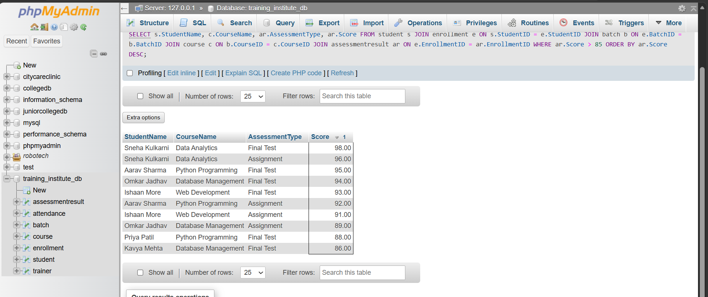
Observation: The query returns 10 assessment records with scores above 85. Sneha Kulkarni achieved the highest score of 98 in the Final Test. The result also shows that students can have multiple qualifying assessment records.

Query 6 — Find the total number of students enrolled in each course
SELECT
c.CourseName,
COUNT(e.EnrollmentID) AS TotalEnrollments
FROM course c
LEFT JOIN batch b
ON c.CourseID = b.CourseID
LEFT JOIN enrollment e
ON b.BatchID = e.BatchID
GROUP BY c.CourseID, c.CourseName;
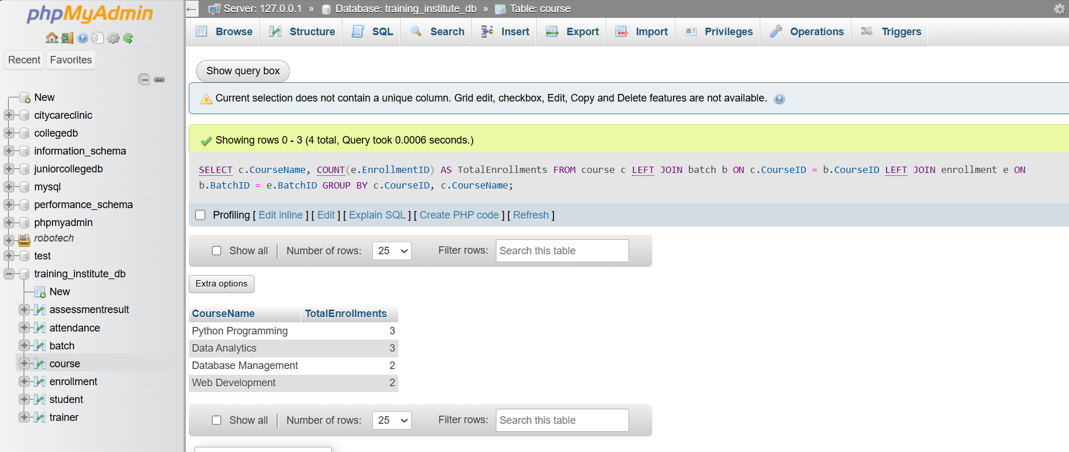
Observation: Python Programming and Data Analytics have the highest number of enrollments, with 3 students each. Database Management and Web Development have 2 enrollments each. The total across all four courses is 10.

Query 7 — Find the trainer assigned to each batch
SELECT
b.BatchName,
t.TrainerName,
c.CourseName,
b.Schedule,
b.Room
FROM batch b
JOIN trainer t
ON b.TrainerID = t.TrainerID
JOIN course c
ON b.CourseID = c.CourseID
ORDER BY b.BatchID;
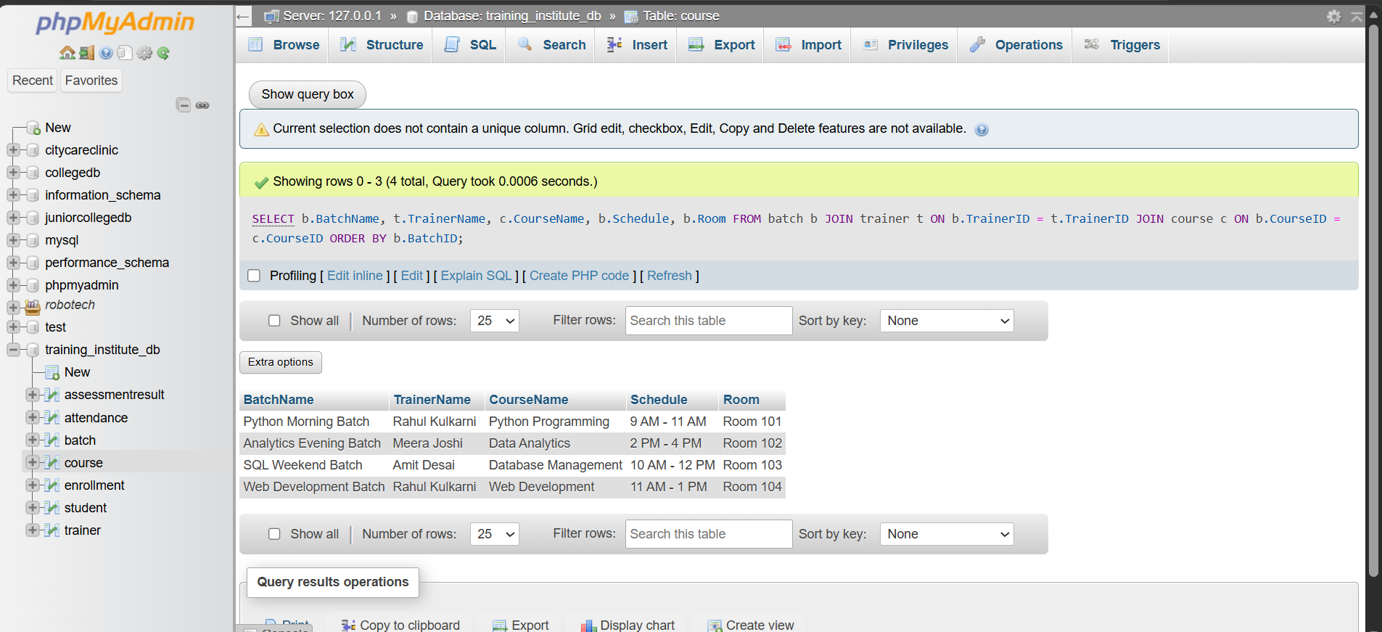

Observation: The query displays all four batches with their respective trainers and schedules. Rahul Kulkarni is assigned to two batches, while Meera Joshi and Amit Desai are each assigned to one batch.

Query 8 — Find the total number of present and absent attendance records
SELECT
Status,
COUNT(*) AS TotalRecords
FROM attendance
GROUP BY Status;
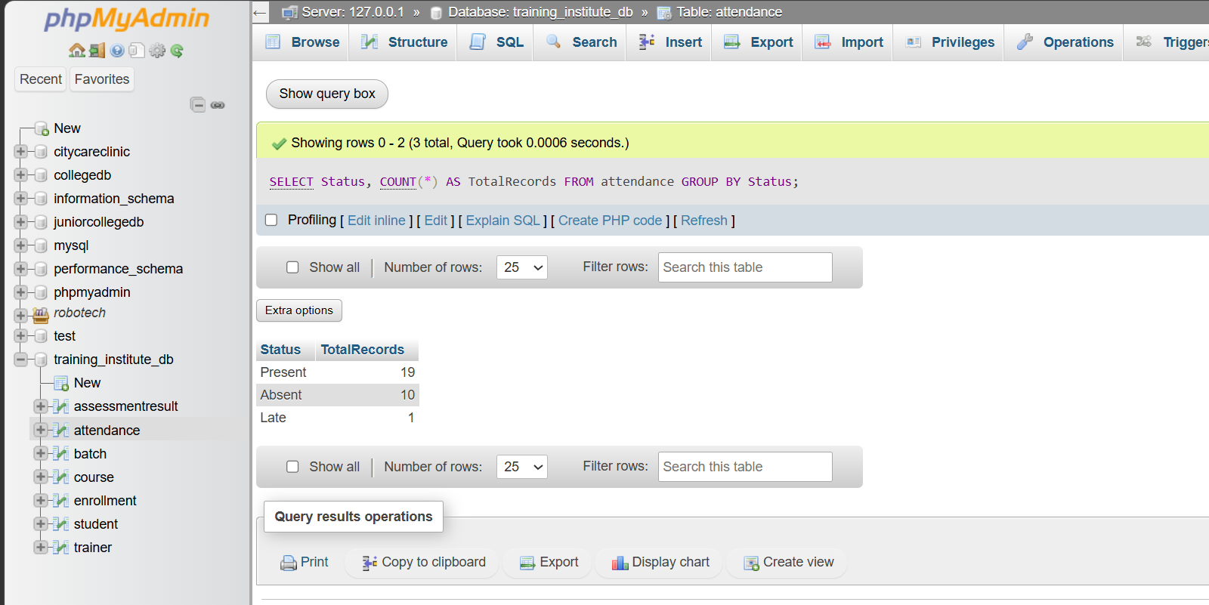
Observation: Out of 30 attendance records, 19 are marked Present, 10 are Absent, and 1 is Late. Present is the most frequently recorded attendance status.

Query 9 — Find the highest assessment score in each course
SELECT
c.CourseName,
MAX(ar.Score) AS HighestScore
FROM course c
JOIN batch b
ON c.CourseID = b.CourseID
JOIN enrollment e
ON b.BatchID = e.BatchID
JOIN assessmentresult ar
ON e.EnrollmentID = ar.EnrollmentID
GROUP BY c.CourseID, c.CourseName;
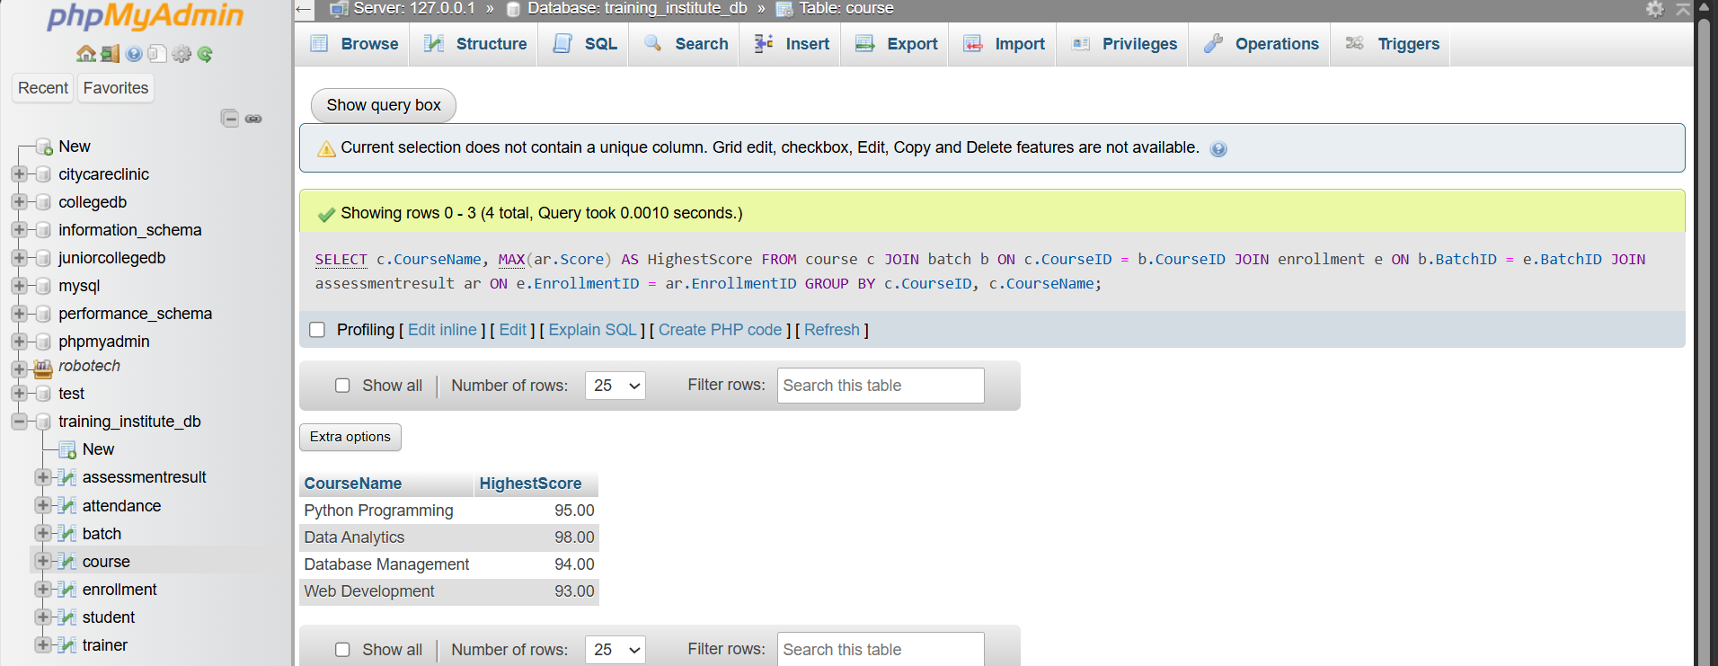
Observation: Data Analytics has the highest score overall, at 98.00. Web Development has the lowest course-wise maximum score, at 93.00.

Query 10 — Display the number of students handled by each trainer
SELECT
t.TrainerName,
COUNT(DISTINCT e.StudentID) AS TotalStudents
FROM trainer t
LEFT JOIN batch b
ON t.TrainerID = b.TrainerID
LEFT JOIN enrollment e
ON b.BatchID = e.BatchID
GROUP BY t.TrainerID, t.TrainerName;
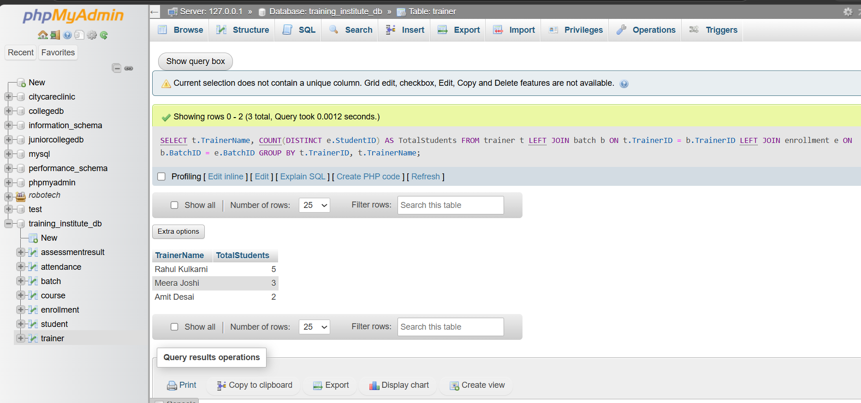
Observation: Rahul Kulkarni handles the highest number of students, with 5 students across two batches. Meera Joshi handles 3 students, while Amit Desai handles 2 students.

Query 11 — Find students who have not attended any session
SELECT
s.StudentID,
s.StudentName
FROM student s
JOIN enrollment e
ON s.StudentID = e.StudentID
LEFT JOIN attendance a
ON e.EnrollmentID = a.EnrollmentID
WHERE a.AttendanceID IS NULL;

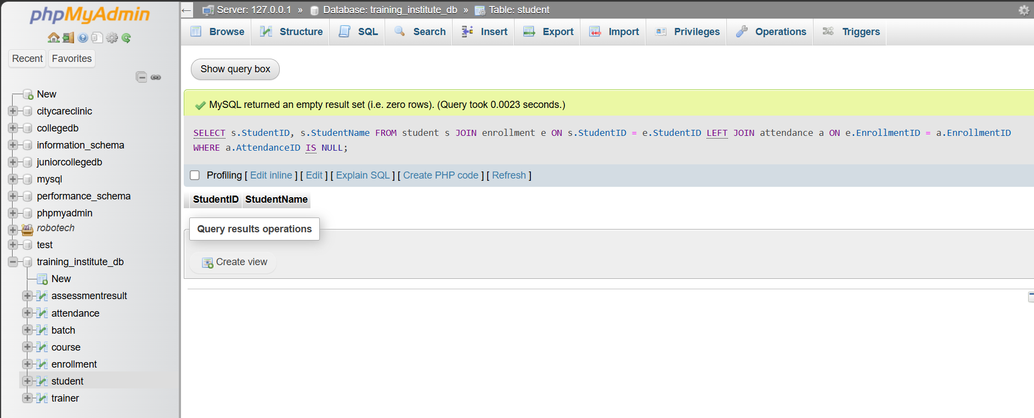
Observation: No enrolled student is missing an attendance record. Therefore, all 10 enrolled students have at least one attendance entry in the database.

Query 12 — Find the average score of each student
SELECT
s.StudentName,
ROUND(AVG(ar.Score), 2) AS AverageScore
FROM student s
JOIN enrollment e
ON s.StudentID = e.StudentID
JOIN assessmentresult ar
ON e.EnrollmentID = ar.EnrollmentID
GROUP BY s.StudentID, s.StudentName
ORDER BY AverageScore DESC;
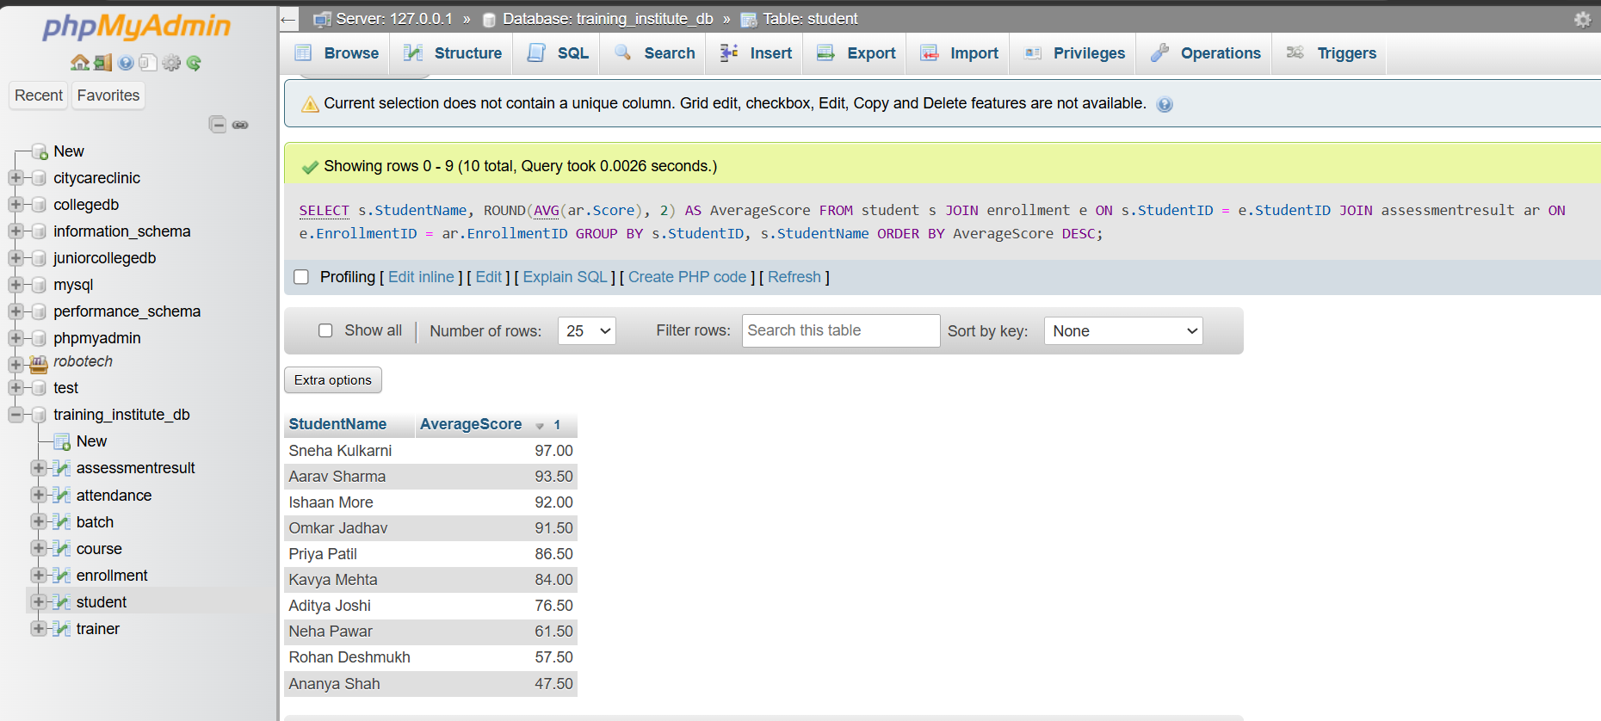
Observation: Sneha Kulkarni has the highest average assessment score of 97.00, while Ananya Shah has the lowest average score of 47.50.

Query 13 — Find the student with the highest average score
SELECT
s.StudentName,
ROUND(AVG(ar.Score), 2) AS AverageScore
FROM student s
JOIN enrollment e
ON s.StudentID = e.StudentID
JOIN assessmentresult ar
ON e.EnrollmentID = ar.EnrollmentID
GROUP BY s.StudentID, s.StudentName
ORDER BY AverageScore DESC
LIMIT 1;
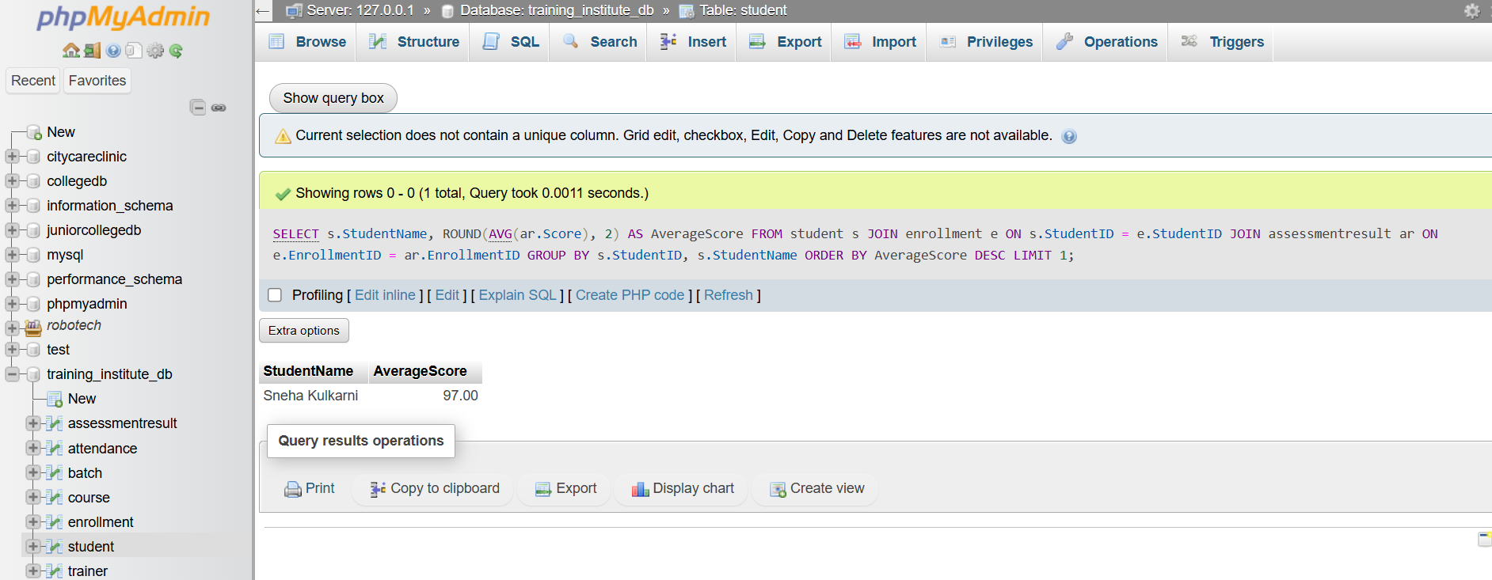
Observation: Sneha Kulkarni is the highest-performing student, with an average assessment score of 97.00.

Query 14 — Find the number of students in each enrollment status
SELECT
Status,
COUNT(*) AS TotalStudents
FROM enrollment
GROUP BY Status;
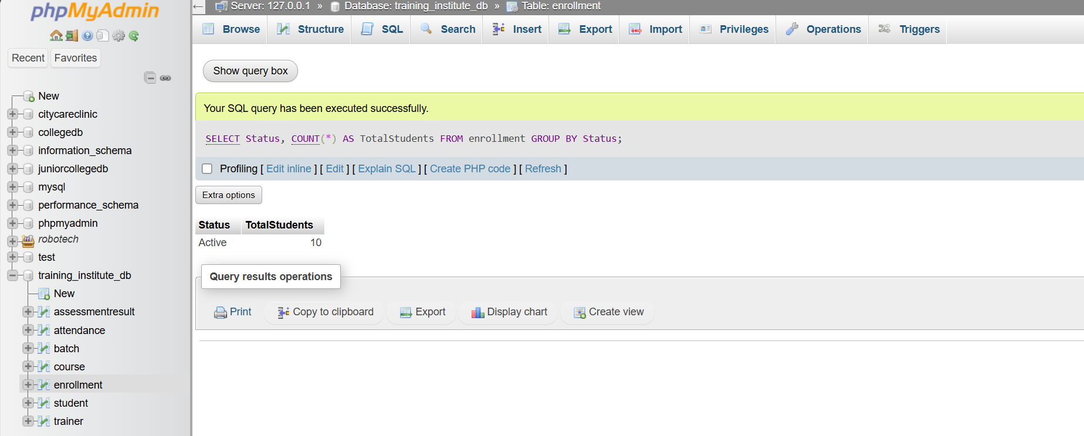
Observation: All 10 enrollment records are currently Active. There are no Completed or Dropped enrollments in the current sample data.

Query 15 — Find the number of assessments of each type
SELECT
AssessmentType,
COUNT(*) AS TotalAssessments
FROM assessmentresult
GROUP BY AssessmentType;
Observation: There are 10 Assignment records and 10 Final Test records, giving a total of 20 assessment records. Each of the 10 enrolled students has one Assignment and one Final Test assessment.
Query 16 — Find the average score for each assessment type
SELECT
AssessmentType,
ROUND(AVG(Score), 2) AS AverageScore
FROM assessmentresult
GROUP BY AssessmentType;
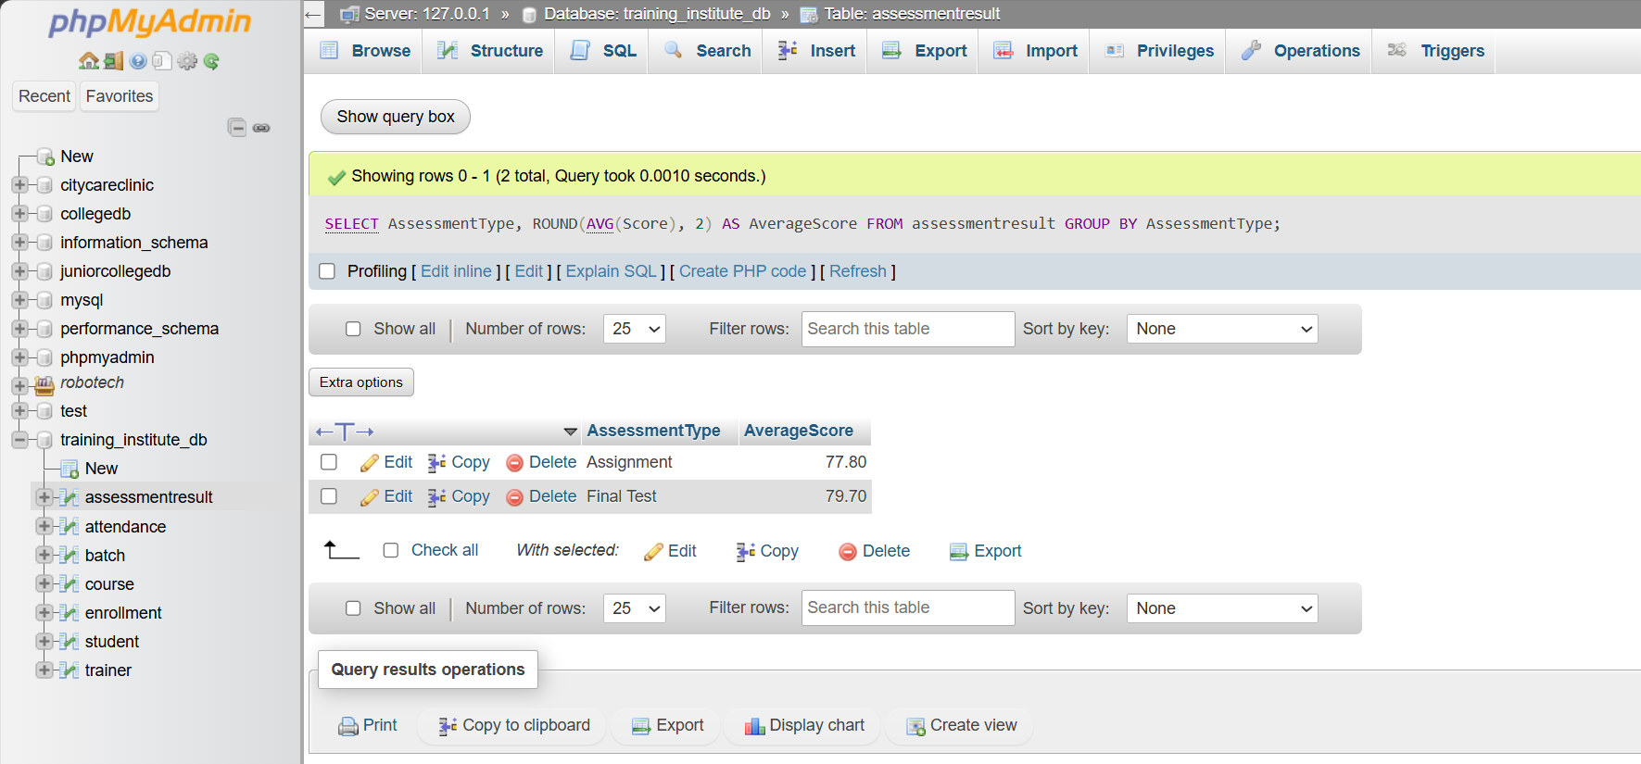
Observation: The average score for the Final Test is 79.70, which is higher than the Assignment average of 77.80.

Query 17 — Find students who scored below 50 in any assessment
SELECT
s.StudentName,
c.CourseName,
ar.AssessmentType,
ar.Score
FROM student s
JOIN enrollment e
ON s.StudentID = e.StudentID
JOIN batch b
ON e.BatchID = b.BatchID
JOIN course c
ON b.CourseID = c.CourseID
JOIN assessmentresult ar
ON e.EnrollmentID = ar.EnrollmentID
WHERE ar.Score < 50
ORDER BY ar.Score ASC;
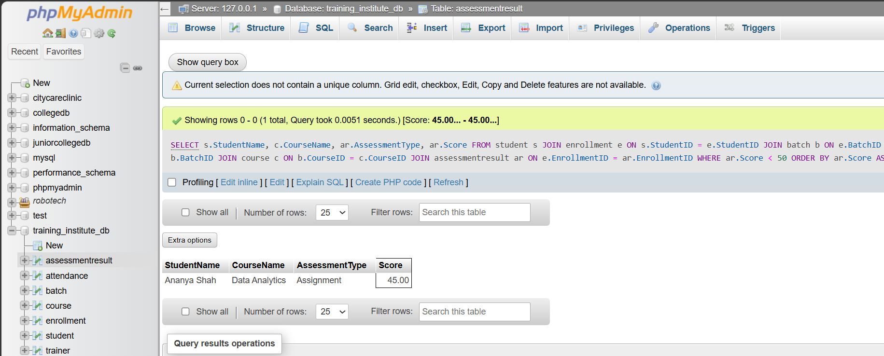
Observation : Only one assessment record has a score below 50. Ananya Shah scored 45 marks in the Assignment for Data Analytics.

Query 18: Find the total number of assessments for each course
SELECT
c.CourseName,
COUNT(ar.AssessmentID) AS TotalAssessments
FROM course c
JOIN batch b
ON c.CourseID = b.CourseID
JOIN enrollment e
ON b.BatchID = e.BatchID
JOIN assessmentresult ar
ON e.EnrollmentID = ar.EnrollmentID
GROUP BY c.CourseID, c.CourseName
ORDER BY TotalAssessments DESC;
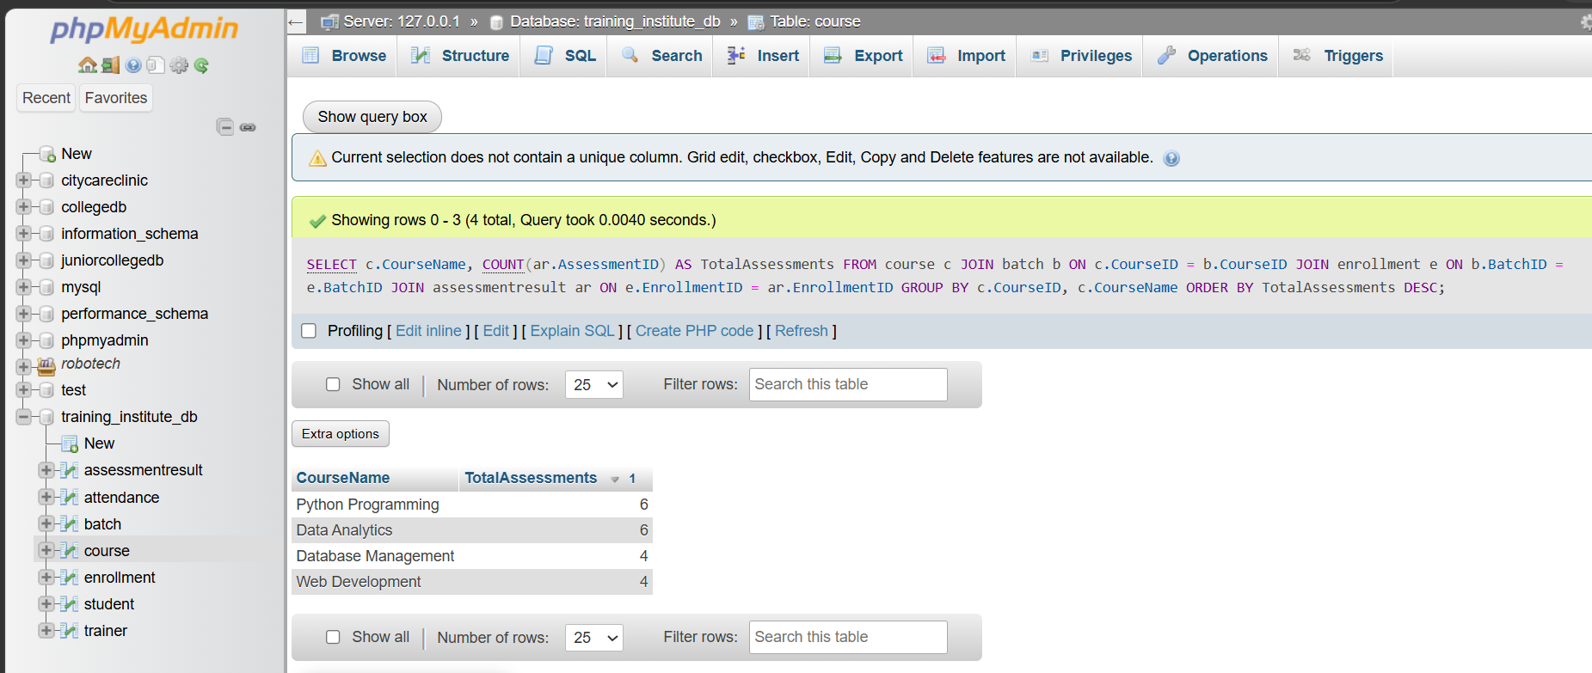
Observation : Python Programming and Data Analytics have the highest number of assessment records, with 6 assessments each. Database Management and Web Development have 4 assessments each.

Query 19: Find the average assessment score for each batch
SELECT
b.BatchName,
ROUND(AVG(ar.Score), 2) AS AverageScore
FROM batch b
JOIN enrollment e
ON b.BatchID = e.BatchID
JOIN assessmentresult ar
ON e.EnrollmentID = ar.EnrollmentID
GROUP BY b.BatchID, b.BatchName
ORDER BY AverageScore DESC;
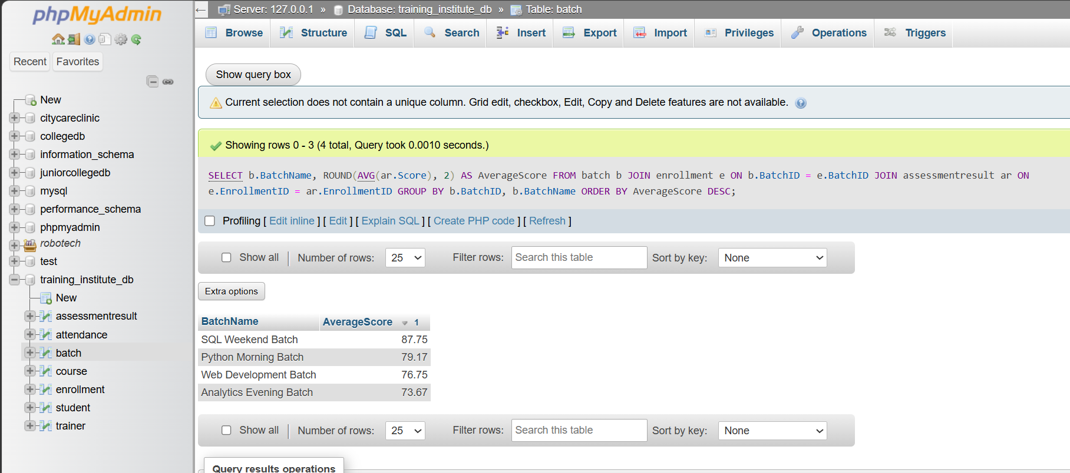
Observation :The SQL Weekend Batch has the highest average assessment score of 87.75, while the Analytics Evening Batch has the lowest average score of 73.67.

Query 20: Classify students based on their average assessment score
SELECT
s.StudentName,
ROUND(AVG(ar.Score), 2) AS AverageScore,
CASE
WHEN AVG(ar.Score) >= 85 THEN 'Excellent'
WHEN AVG(ar.Score) >= 70 THEN 'Good'
WHEN AVG(ar.Score) >= 50 THEN 'Average'
ELSE 'Needs Improvement'
END AS PerformanceLevel
FROM student s
JOIN enrollment e
ON s.StudentID = e.StudentID
JOIN assessmentresult ar
ON e.EnrollmentID = ar.EnrollmentID
GROUP BY s.StudentID, s.StudentName
ORDER BY AverageScore DESC;
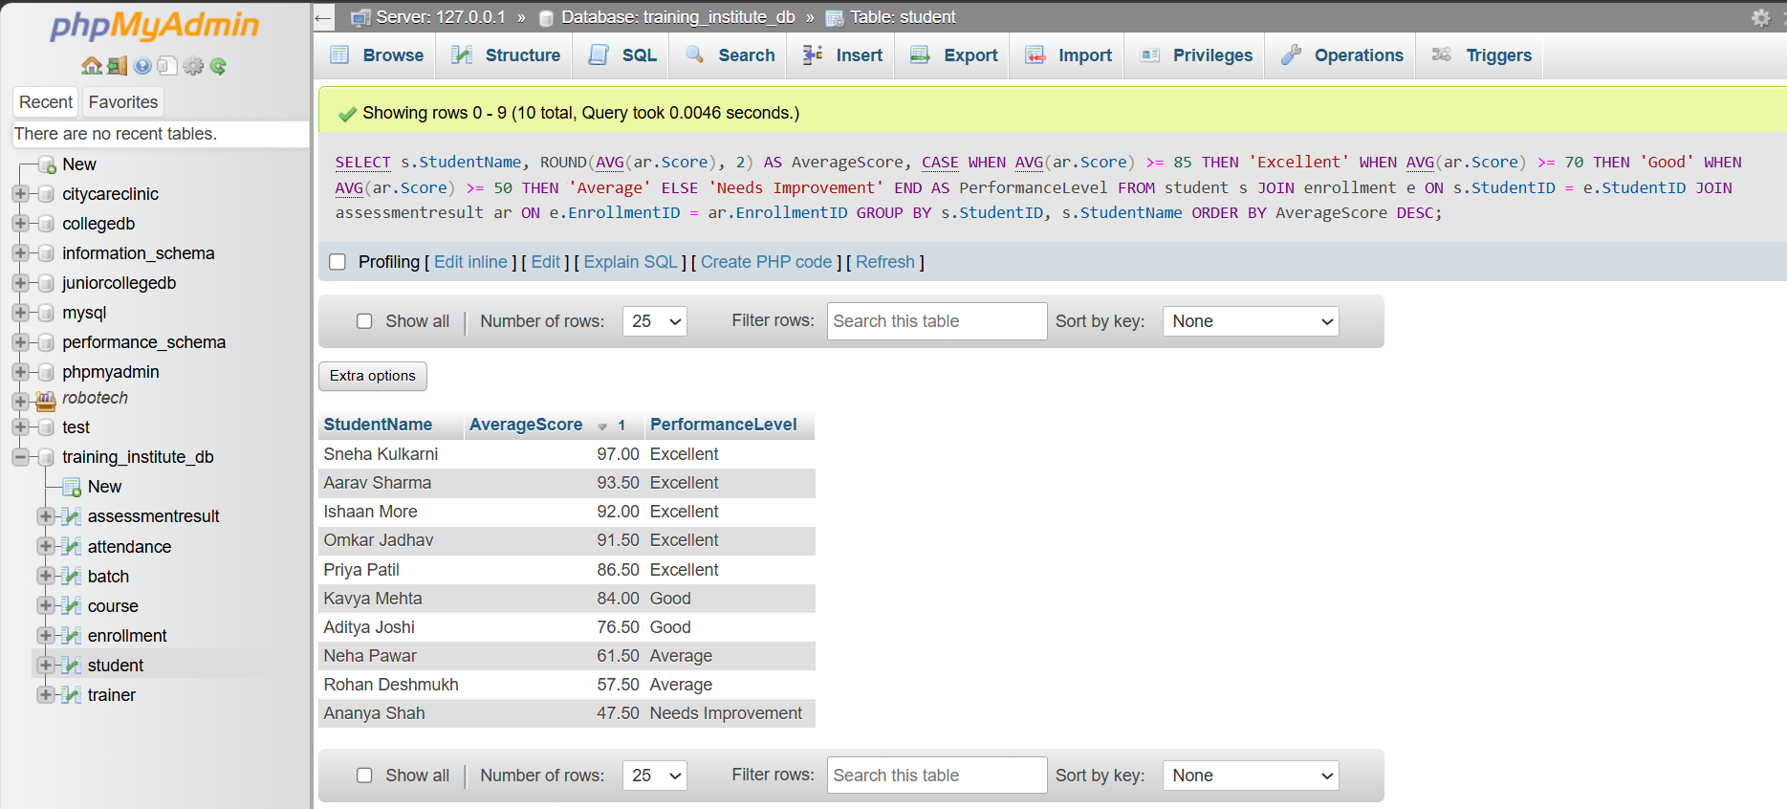
Observation
The query classifies students according to their average assessment scores. Five students are in the Excellent category, two students are in the Good category, two students are in the Average category, and one student needs improvement. Sneha Kulkarni has the highest average score of 97.00

Business Queries and Data Analysis

Query 1 — Display all students enrolled in each batch

SELECT
b.BatchName,
s.StudentID,
s.StudentName,
c.CourseName,
e.EnrollDate,
e.Status
FROM batch b
JOIN enrollment e
ON b.BatchID = e.BatchID
JOIN student s
ON e.StudentID = s.StudentID
JOIN course c
ON b.CourseID = c.CourseID
ORDER BY b.BatchID, s.StudentID;
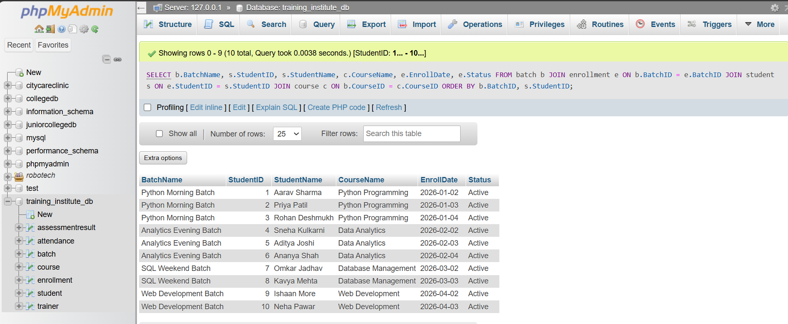

Query 2 — Display the Course and Trainer Assigned to Every Batch
SELECT
b.BatchName,
c.CourseName,
t.TrainerName
FROM batch b
JOIN course c
ON b.CourseID = c.CourseID
JOIN trainer t
ON b.TrainerID = t.TrainerID
ORDER BY b.BatchID;
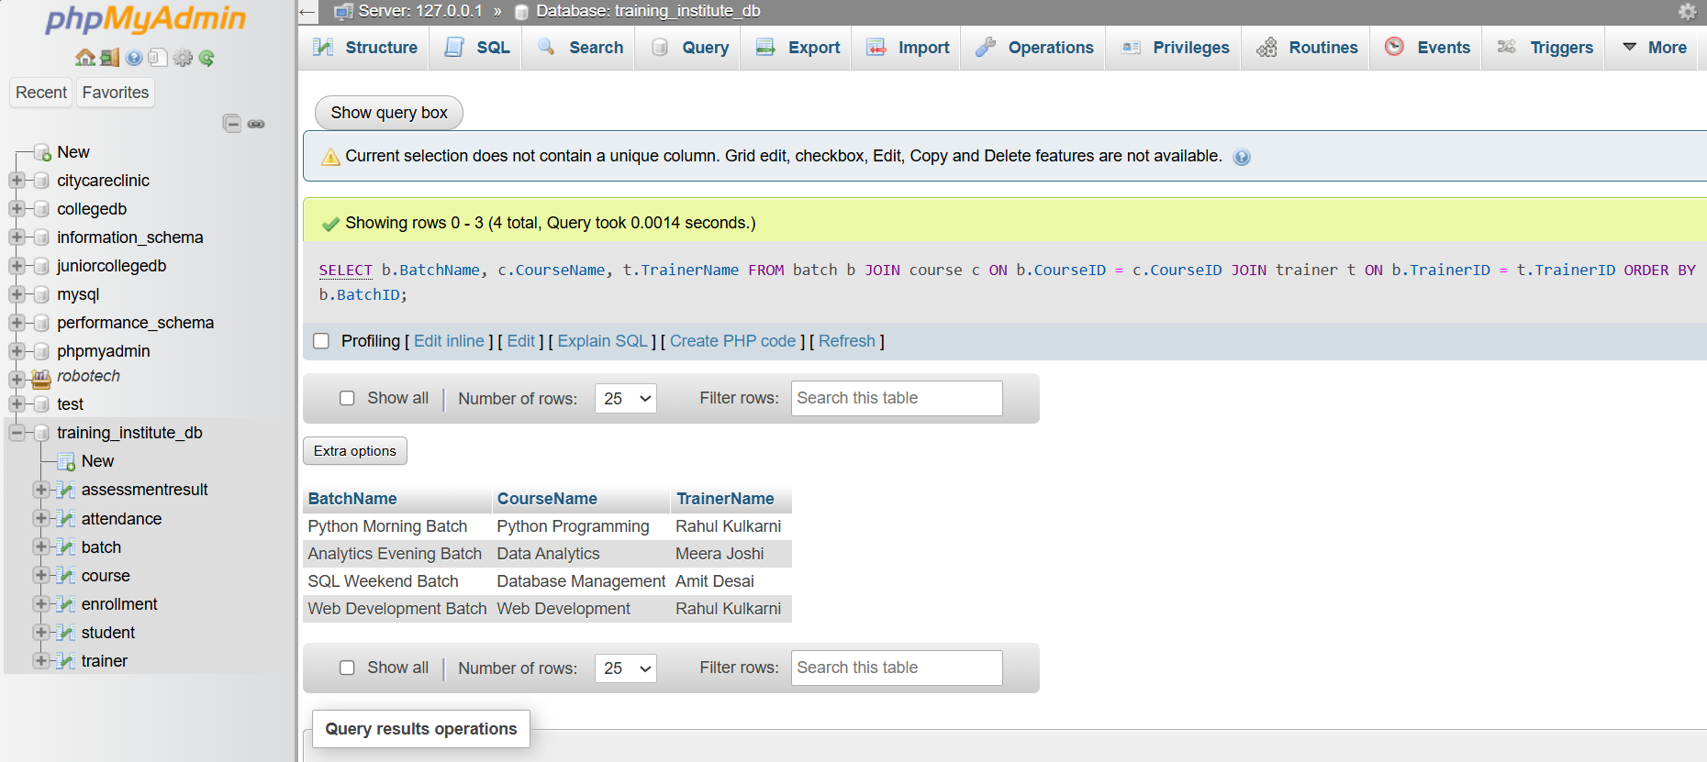

Query 3 — Find the Total Number of Students in Each Course
SELECT
c.CourseName,
COUNT(e.EnrollmentID) AS TotalStudents
FROM course c
JOIN batch b
ON c.CourseID = b.CourseID
JOIN enrollment e
ON b.BatchID = e.BatchID
GROUP BY c.CourseID, c.CourseName
ORDER BY c.CourseID;
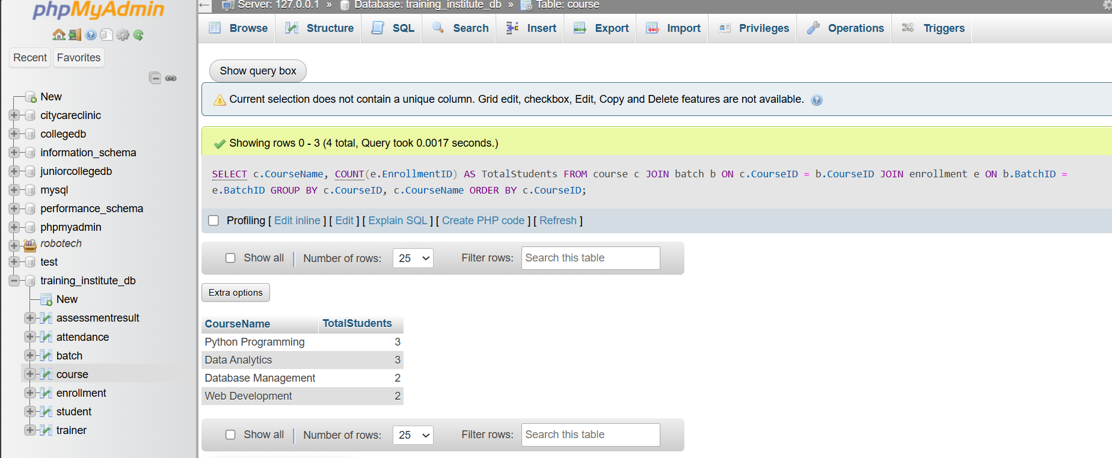

Query 4— Find Batches Having More Than a Specified Number of Students
SELECT
b.BatchName,
COUNT(e.EnrollmentID) AS TotalStudents
FROM batch b
JOIN enrollment e
ON b.BatchID = e.BatchID
GROUP BY b.BatchID, b.BatchName
HAVING COUNT(e.EnrollmentID) > 2;
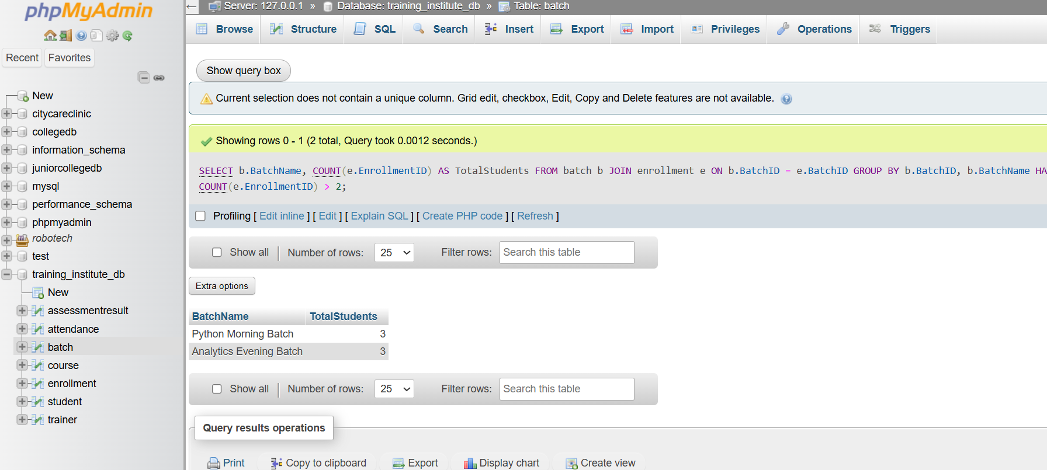

Query 5 — Display Students Whose Attendance Is Below the Required Percentage
SELECT
s.StudentName,
ROUND(
SUM(CASE WHEN a.Status = 'Present' THEN 1 ELSE 0 END)
* 100.0 / COUNT(a.AttendanceID),
2
) AS AttendancePercentage
FROM student s
JOIN enrollment e
ON s.StudentID = e.StudentID
JOIN attendance a
ON e.EnrollmentID = a.EnrollmentID
GROUP BY s.StudentID, s.StudentName
HAVING AttendancePercentage < 75
ORDER BY AttendancePercentage;

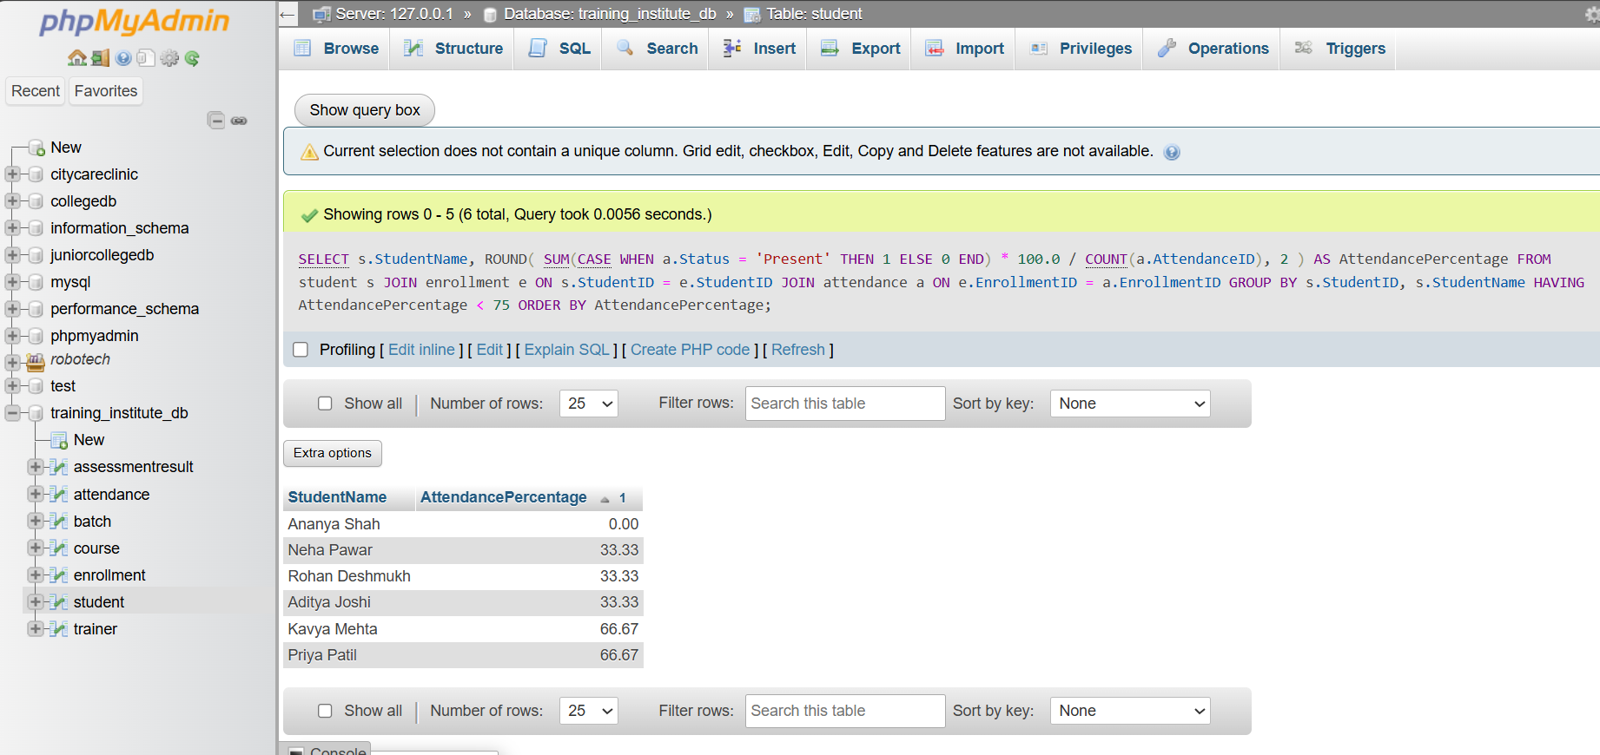

Query 6— Find the Average Assessment Score for Each Batch
SELECT
b.BatchName,
ROUND(AVG(ar.Score), 2) AS AverageAssessmentScore
FROM batch b
JOIN enrollment e
ON b.BatchID = e.BatchID
JOIN assessmentresult ar
ON e.EnrollmentID = ar.EnrollmentID
GROUP BY b.BatchID, b.BatchName
ORDER BY AverageAssessmentScore DESC;
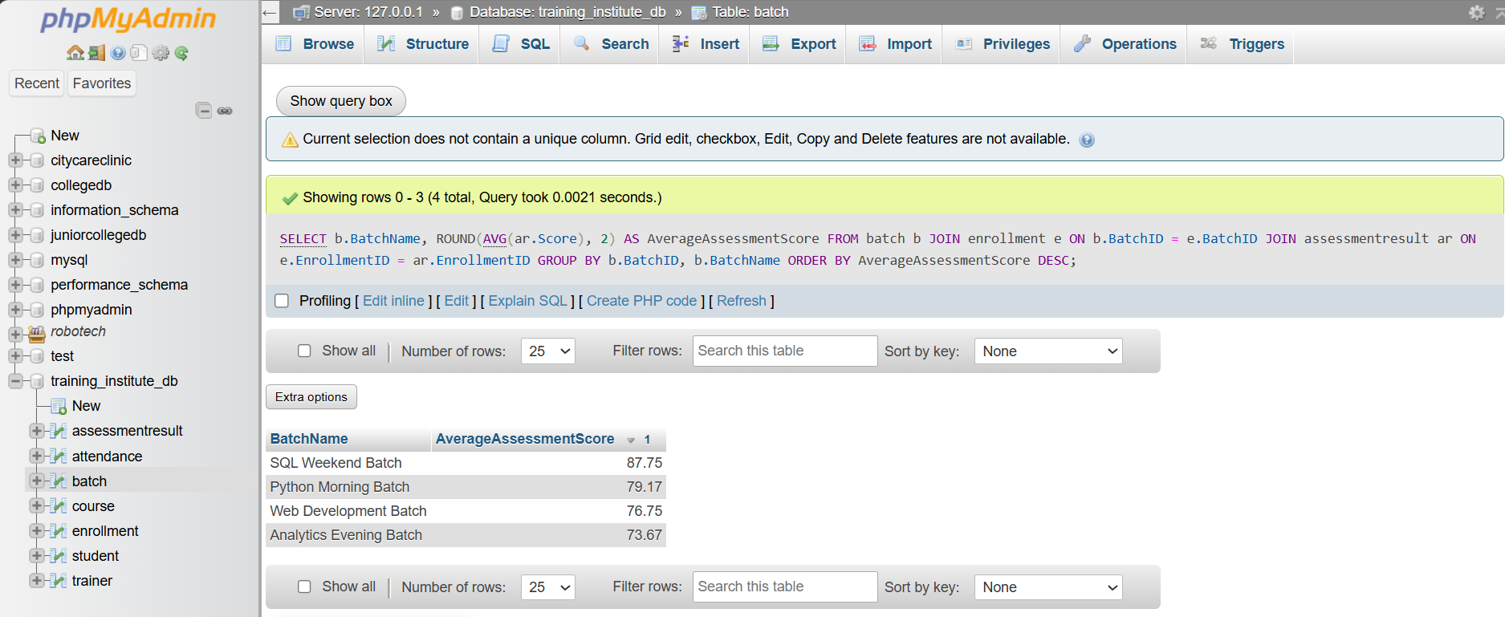

Query 7 — Identify the Highest-Performing Student in Every Batch
SELECT
BatchName,
StudentName,
AverageScore
FROM (
SELECT
b.BatchName,
s.StudentName,
ROUND(AVG(ar.Score), 2) AS AverageScore,
RANK() OVER (
PARTITION BY b.BatchID
ORDER BY AVG(ar.Score) DESC
) AS StudentRank
FROM batch b
JOIN enrollment e
ON b.BatchID = e.BatchID
JOIN student s
ON e.StudentID = s.StudentID
JOIN assessmentresult ar
ON e.EnrollmentID = ar.EnrollmentID
GROUP BY
b.BatchID,
b.BatchName,
s.StudentID,
s.StudentName
) ranked_students
WHERE StudentRank = 1;
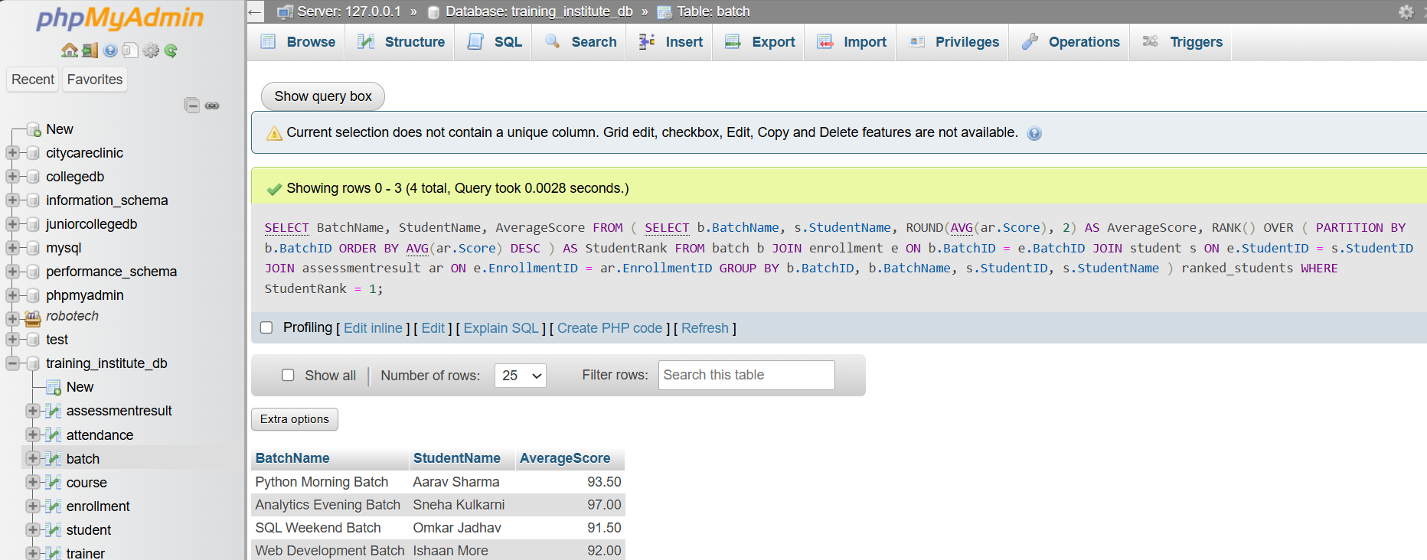

Query 8— Display Students Who Have Not Attended Any Session
SELECT
s.StudentID,
s.StudentName
FROM student s
JOIN enrollment e
ON s.StudentID = e.StudentID
LEFT JOIN attendance a
ON e.EnrollmentID = a.EnrollmentID
WHERE a.AttendanceID IS NULL;
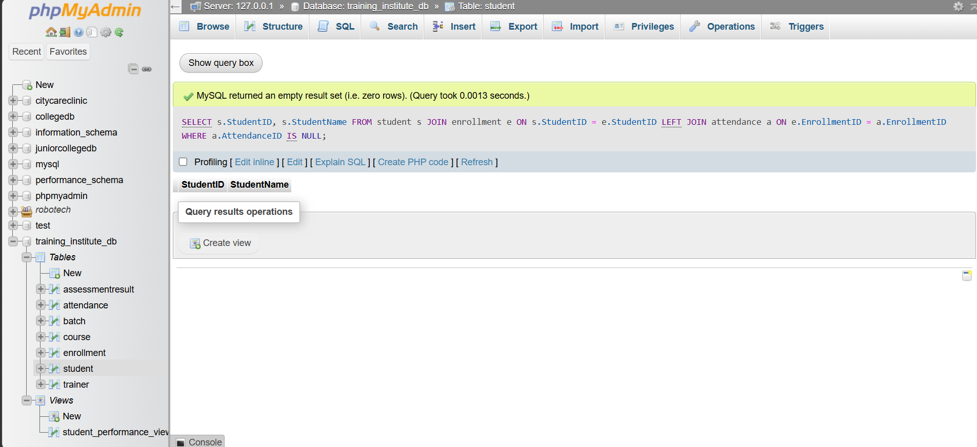

Query 9— Compare Course-wise Student Performance
SELECT
c.CourseName,
ROUND(AVG(ar.Score), 2) AS AverageStudentPerformance
FROM course c
JOIN batch b
ON c.CourseID = b.CourseID
JOIN enrollment e
ON b.BatchID = e.BatchID
JOIN assessmentresult ar
ON e.EnrollmentID = ar.EnrollmentID
GROUP BY c.CourseID, c.CourseName
ORDER BY AverageStudentPerformance DESC;
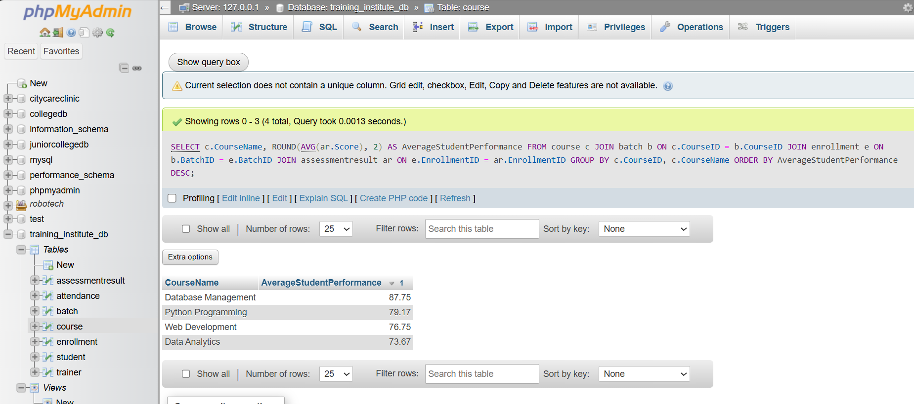

Query 10 — Rank Students According to Assessment Results
SELECT
s.StudentName,
ROUND(AVG(ar.Score), 2) AS AverageScore,
RANK() OVER (
ORDER BY AVG(ar.Score) DESC
) AS StudentRank
FROM student s
JOIN enrollment e
ON s.StudentID = e.StudentID
JOIN assessmentresult ar
ON e.EnrollmentID = ar.EnrollmentID
GROUP BY s.StudentID, s.StudentName
ORDER BY StudentRank;
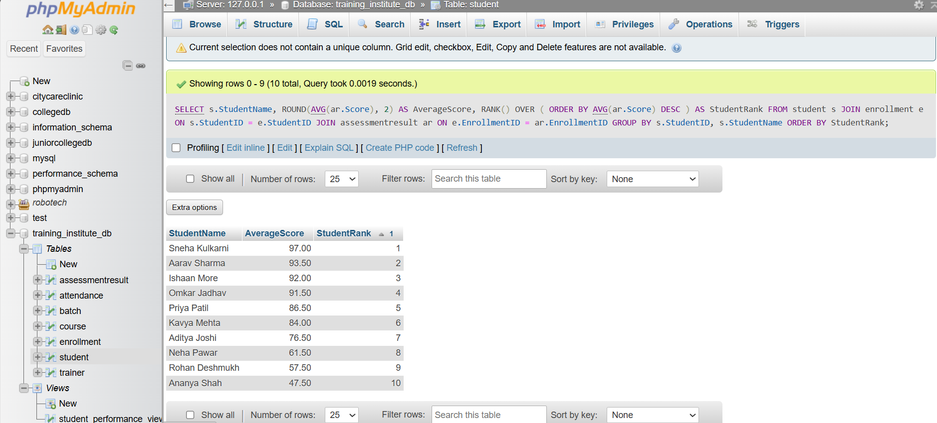

Query 11 - Find batches with the highest and lowest average attendance.
SELECT
s.StudentName,
ROUND(AVG(ar.Score), 2) AS AverageScore,
RANK() OVER (
ORDER BY AVG(ar.Score) DESC
) AS StudentRank
FROM student s
JOIN enrollment e
ON s.StudentID = e.StudentID
JOIN assessmentresult ar
ON e.EnrollmentID = ar.EnrollmentID
GROUP BY s.StudentID, s.StudentName
ORDER BY StudentRank;
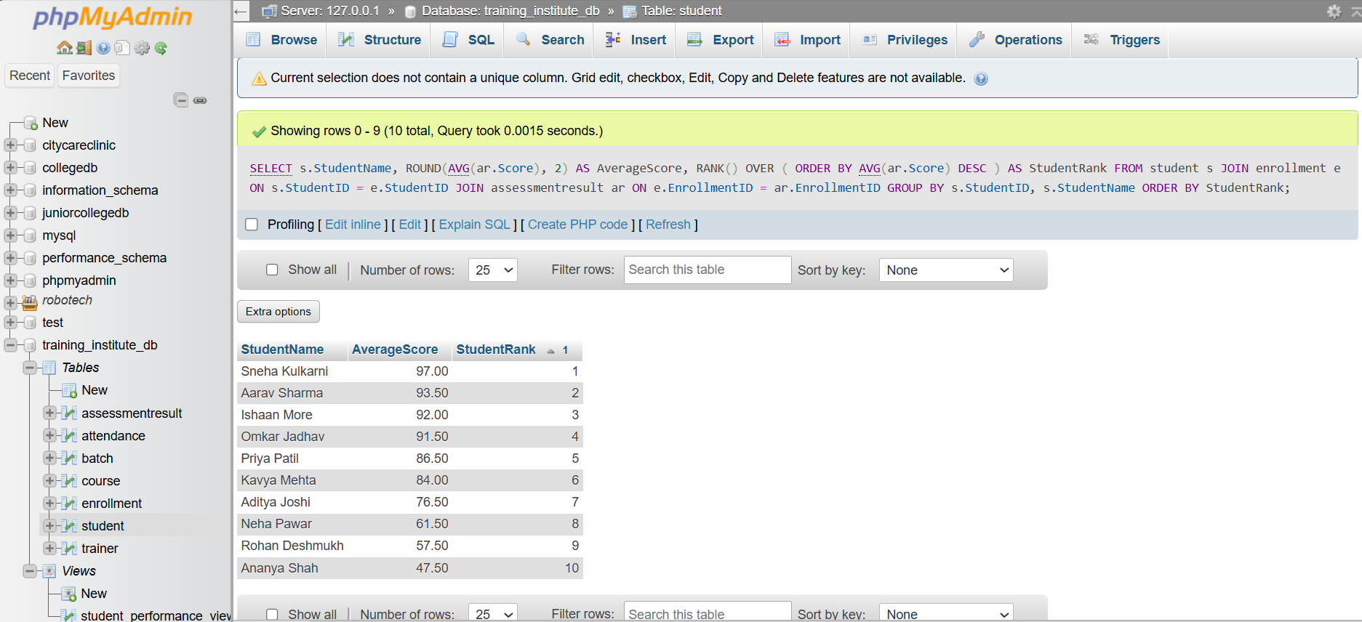

Views

CREATE VIEW student_performance_view AS
SELECT
s.StudentID,
s.StudentName,
c.CourseName,
b.BatchName,
ROUND(AVG(ar.Score), 2) AS AverageScore
FROM student s
JOIN enrollment e
ON s.StudentID = e.StudentID
JOIN batch b
ON e.BatchID = b.BatchID
JOIN course c
ON b.CourseID = c.CourseID
JOIN assessmentresult ar
ON e.EnrollmentID = ar.EnrollmentID
GROUP BY
s.StudentID,
s.StudentName,
c.CourseName,
b.BatchName;
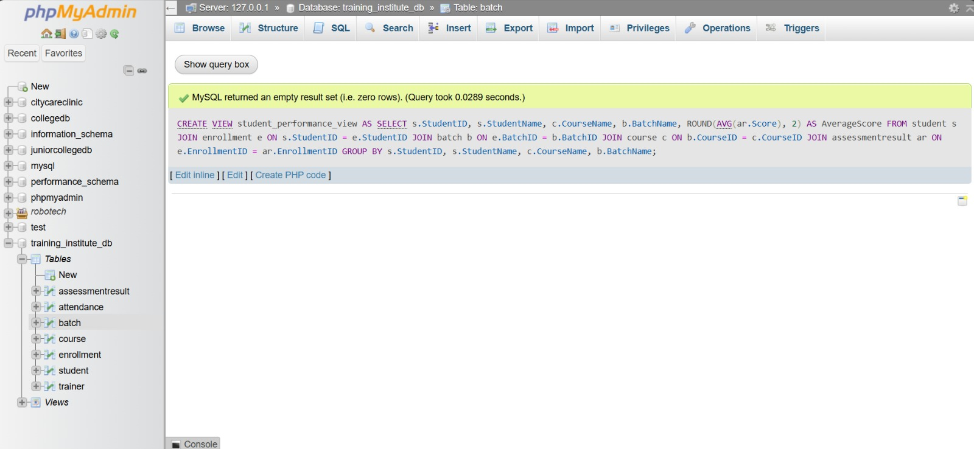
SELECT *
FROM student_performance_view
ORDER BY AverageScore DESC;
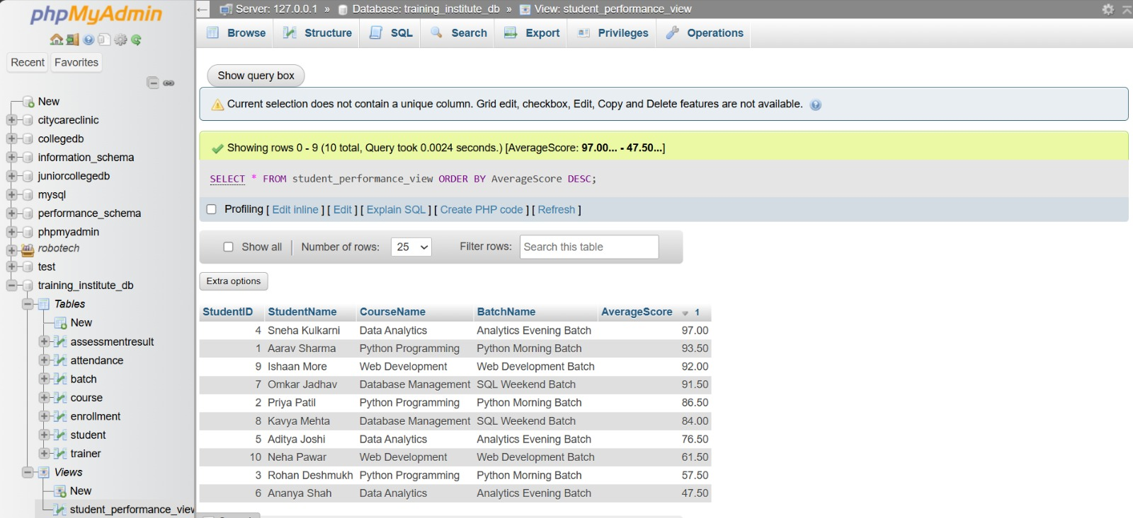

Overall Insights

The SQL analysis of the Training Institute Management System produced the following important insights:
- The database contains 10 students, 3 trainers, 4 courses, 4 batches, 10 enrollments, 30 attendance records, and 20 assessment records.
- Python Programming and Data Analytics have the highest enrollment, with 3 students each.
- Database Management has the highest course-level average assessment score of 87.75.
- SQL Weekend Batch has the highest batch-level average score of 87.75.
- Sneha Kulkarni is the top-performing student with an average score of 97.00.
- The highest individual assessment score is 98 in Data Analytics.
- Six students have attendance below 75%, indicating the need for attendance monitoring.
- There are 19 Present, 10 Absent, and 1 Late attendance records.
- All 10 sample enrollments currently have Active status.
- Five students are classified as Excellent, two as Good, two as Average, and one as Needs Improvement.
- Every enrolled student has at least one attendance record.
- Each student has one Assignment and one Final Test assessment in the sample data.

Findings
The developed Training Institute Management System successfully integrates student, trainer, course, batch, enrollment, attendance, and assessment information into a relational database.
The analysis shows that the system can be used to monitor student enrollment, attendance, academic performance, trainer workload, and batch performance. SQL queries provide useful information for identifying high-performing students as well as students who may require additional academic or attendance support.
The use of aggregate functions, joins, filtering, grouping, ordering, and conditional logic demonstrates that the database can support meaningful management-level analysis.

Outcome
The Training Institute Management System was successfully designed and implemented using a relational database approach. The required tables, relationships, sample records, and SQL queries were created and tested.
The system provides useful reports related to:
- Student enrollment
- Course and batch allocation
- Trainer assignment
- Attendance monitoring
- Assessment performance
- Student ranking
- Batch performance
- Academic performance classification
The SQL analysis demonstrates how a database management system can convert stored institutional data into useful information for decision-making.

Conclusion
The Training Institute Management System provides an organized and efficient method for managing training institute data. The relational database structure reduces data redundancy and maintains relationships between students, courses, trainers, batches, enrollments, attendance, and assessment results.
The implementation of SQL queries successfully demonstrates data retrieval, filtering, grouping, aggregation, sorting, and conditional analysis. The generated results can help institute administrators and trainers monitor student progress, identify students requiring attention, evaluate batch performance, and make informed decisions.
Thus, the project successfully achieves its objective of developing a database system for managing and analyzing the activities of a training institute.

